Skills for Work

Rural Skills: Animal Handling: An Introduction (Sheep)

(Intermediate 1)

Support Material

July 2006

Scottish Further Education Unit

Acknowledgements

SFEU is grateful to the subject specialists in Scotland’s Colleges and other agencies and industry bodies who have been involved in the writing of this and other support materials in the Skills for Work series.

SFEU is also grateful for the contribution of the Scottish Qualifications Authority in the compilation of these materials, specifically for its permission to reproduce extracts from Course and Unit Specifications and the Skills for Work Rationale, and to LANTRA for help and advice.

Clip art in this pack is reproduced by kind permission of Bayer Healthcare, Animal Health Division, Bayer House, Strawberry Hill, Newbury, Berkshire, RG14 1JA.

© Scottish Further Education Unit 2006
Rural Skills: Animal Handling: An Introduction (Sheep), Intermediate 1

DX0Y 10

Introduction

These notes are provided to support teachers and lecturers presenting the Scottish Qualifications Authority Unit DX0Y10 Rural Skills: Animal Handling: An Introduction (Sheep). Copyright for this pack is held by the Scottish Further Education Unit (SFEU). However, teachers and lecturers have permission to use the pack and reproduce items from the pack provided that this is to support teaching and learning processes and that no profit is made from such use. If reproduced in part, the source should be acknowledged.

Enquiries relating to this Support Pack or issues relating to copyright should be addressed to:

Marketing Officer - Communications
The Scottish Further Education Unit
Argyll Court
Castle Business Park
Stirling
FK9 4TY

Website: www.sfeu.ac.uk

Further information regarding this Unit including Unit Specification, National Assessment Bank materials, Centre Approval and certification can be obtained from:

The Scottish Qualifications Authority
Optima Building
58 Robertson Street
Glasgow
G2 8DQ

Website: www.sqa.org.uk

Whilst every effort has been made to ensure the accuracy of this Support Pack, teachers and lecturers should satisfy themselves that the information passed to candidates is accurate and in accordance with the current SQA arrangements documents. SFEU will accept no responsibility for any consequences deriving either directly or indirectly from the use of this Pack.
Contents

Reference Section 7
What are Skills for Work Courses all about? 8
The Course in Rural Skills (Intermediate 1) 11
Unit Outcomes, PCs and Evidence Requirements 13
Employability Skills Profile 15
Tutor Support Section 16
How to use this pack 17
Guidance on Delivery of Animal Handling: An Introduction (Sheep) 19
Employability Skills 21
Integrating the Content of the Employability Skills Unit 21
Generating Evidence and Assessment Opportunities for Employability Skills 23
Resources 24
Learning and Teaching with Under 16s 28
Skills for Work Workshops 31
Student Support Section 32
Welcome to Animal Handling (Sheep) 33
What is Sheep Handling all about? 34
Understanding Sheep 37
Being Safe around Sheep 41
Moving and Restraining Sheep 44
Catching and Restraining Sheep 49
Tips and Techniques for Handling Sheep 53
Practical Activities Worksheets 58
Practical Assessment Checklist 63
Further Revision 64
Glossary of Terms 66

Reference Section

What are Skills for Work Courses all about?

Skills for Work Courses are designed to help candidates to develop:
- skills and knowledge in a broad vocational area
- Core Skills
- an understanding of the workplace
- positive attitudes to learning
- skills and attitudes for employability

A key feature of these Courses is the emphasis on experiential learning. This means learning through practical experience and learning by reflecting on experience.

Learning through practical experience

Teaching/learning programmes should include some or all of the following:
- learning in real or simulated workplace settings
- learning through role play activities in vocational contexts
- carrying out case study work
- planning and carrying out practical tasks and assignments

Learning through reflecting at all stages of the experience

Teaching/learning programmes should include some or all of the following:
- preparing and planning for the experience
- taking stock throughout the experience
- reviewing and adapting as necessary
- reflecting after the activity has been completed
- evaluating, self-assessing and identifying learning points

The Skills for Work Courses are also designed to provide candidates with opportunities for developing Core Skills and enhancing skills and attitudes for employability.

Core Skills

The five Core Skills are:
- Communication
- Numeracy
- Information Technology
- Problem Solving
- Working with Others

Opportunities to develop aspects of Core Skills are highlighted in Guidance on Teaching and Learning Approaches.

Employability

The skills and attitudes for employability, including self-employment, are outlined below:
- generic skills/attitudes valued by employers
  - understanding of the workplace and the employee’s responsibilities, for example time-keeping, appearance, customer care
  - self-evaluation skills
  - positive attitude to learning
  - flexible approaches to solving problems
  - adaptability and positive attitude to change
  - confidence to set goals, reflect and learn from experience
- specific vocational skills/knowledge
  - Course Specifications highlight the links to National Occupational Standards in the vocational area and identify progression opportunities

Opportunities for developing these skills and attitudes are highlighted in each of the Course and Unit Specifications. These opportunities include giving young people direct access to workplace experiences or, through partnership arrangements, providing different learning environments and experiences which simulate aspects of the workplace. These experiences might include visits, visiting speakers, role play and other practical activities.

A Curriculum for Excellence (Scottish Executive 2004) identifies aspirations for every young person. These are that they should become:
- successful learners
- confident individuals
- responsible citizens
- effective contributors

The learning environments, the focus on experiential learning and the opportunities to develop employability and Core Skills in these Courses contribute to meeting these aspirations.

The Course in Rural Skills (Intermediate 1)

Course Rationale

The land-based sector is very diverse and includes a wide number of disciplines that share a common element of being active, practical and mainly based outdoors. The major disciplines that are recognised as land-based by the sector skills council for the area include the following: agricultural crops; fencing industries; land-based engineering industries; production horticulture industries; tree and timber related industries; environmental conservation industries; landscaping industries; agricultural livestock; animal care industries; aquaculture; equine industries; farriery; fisheries management; game and wildlife management and veterinary industries.

There is a very wide range of land-based businesses in Scotland with a great variety of job roles. Changes in rural land use, including the decline and change of traditional agriculture, have created a knowledge gap. Research has indicated that fewer people are likely to contribute to the rural economy and its development unless more individuals are introduced to the possible opportunities in land-based industries in the UK.

This Rural Skills Course has been designed to provide a broad basis for progression into further education and training in the land-based sector. It allows candidates to begin to develop some of the basic practical skills necessary to work in most of these disciplines as well as an opportunity to explore the very diverse employment prospects that exist.

The primary target group for the course is school candidates in S3 and S4. It is anticipated that, for this group of candidates, the course will rely on and build on existing partnerships between schools and further education colleges delivering specialisms in land-based industries. It may also be delivered in conjunction with training providers or employers specialising in the land-based industries. These partnerships will enable the course to be delivered in a variety of appropriate learning environments with access to relevant teaching expertise.

The course has been designed with a common core that allows candidates to develop an insight into the numerous opportunities of the land-based industries and to develop the basic common skills of the sector. It also allows candidates to choose a route that is related to either animals or plants where they can develop specific basic practical skills in that general category.

The general aims of the course are to:

- widen participation in vocationally-related learning for 14–16 year olds

- allow candidates to experience vocationally-related learning

- provide candidates with a broad introduction to the land-based sector

- encourage candidates to develop a good work ethic including reliability, flexibility and a positive attitude to work

- provide opportunities to develop Core Skills in a realistic context

- encourage candidates to take charge of their own learning and development

- provide a range of teaching, learning and assessment styles to motivate candidates to achieve their full potential

- facilitate progression to further education and/or training

The specific aims of this course are to:

- introduce candidates to the various disciplines of the land-based sector

- allow candidates to develop a basic knowledge of a selection of land-based industries and related job roles

- allow candidates to experience an outdoor working environment

- allow candidates to develop an understanding of the very flexible requirements of the individual who works with plants and/or animals

- allow candidates to develop an awareness of health and safety issues that are integral to a career in a land-based industry

- allow candidates to develop the technical knowledge, skills and understanding of some of the commonly used practical skills associated with land-based industries at this level

- introduce candidates to the technical knowledge, skills and understanding of some specific practical skills associated with a selection of land-based industries at this level

- prepare candidates for more focused further learning opportunities, study and training for employment in land-based industries

Unit Outcomes, PCs and Evidence Requirements

Unit Specification: statement of standards

Unit: Animal Handling: An Introduction (Intermediate 1)

Acceptable performance in this Unit will be the satisfactory achievement of the standards set out in this part of the Unit specification. All sections of the statement of standards are mandatory and cannot be altered without reference to the Scottish Qualifications Authority.

Outcome 1

Assist with the movement and control of animals.

Performance Criteria

- Contribute to a method of movement that ensures stress is minimised for the animals at all times.
- Demonstrate an understanding of the behaviour of animals when being moved.
- Demonstrate safe working practices.

Outcome 2

Assist with the restraint of animals for the purpose of examination.

Performance Criteria

- Assist in catching an identified animal that is loose in an enclosure.
- Effectively assist in using one type of restraint appropriate for the animal.
- Assist in the presentation of an animal for examination.
- Demonstrate safe working practices.

Evidence Requirements For This Unit

Performance evidence supported by an assessor observation checklist is required to show that all Outcomes and Performance Criteria have been achieved.

Evidence must be gathered in an appropriate context where live animals are kept in work settings or simulated work settings.

For each Outcome, evidence is required in relation to one or more categories of animal. The animal(s) can be selected from the following:

- horses
- sheep
- cattle
- pigs
- game birds
- small ‘cage’ companion mammals
- domestic dogs
- domestic cats

Candidates should be involved in the movement of at least two animals for a given purpose which has been explained to the candidate.

The assessor observation checklist confirms that the candidate:

- has contributed to a stress-free movement of animals
- demonstrated an understanding of behaviour of animals being moved
- has assisted in catching the identified animal
- has assisted in presenting the animal for examination
- demonstrated safe working practices throughout

The assessor may choose to carry out the different assessment activities on separate occasions.
The item for this Unit contains assessor observation checklists. The NAB illustrates the national standard required for this Unit. Centres who wish to devise their own assessments should refer to the NAB to ensure a comparable standard.

NB Centres must refer to the full Unit Specification for detailed information related to this Unit.

Employability Skills Profile

Employability Skills Profile: Hairdressing (Intermediate 1) | Hairdressing: Salon Awareness = A | Hairdressing: Working in the Salon = B | Hairdressing: Employability Skills = C | Hairdressing: Creativity = D | In addition to the specific, vocational skills developed and assessed in this Course, employability skills are addressed as detailed below: | Evidence | A,C | A,C | A,C | B,C | A,B,C | B,C | C | A,B,C | B,D | B,D | A,B,D | A | A,B | C | D | C |  | A = candidate folio of information gathered on salon roles and responsibilities and health and safety and assessor observation checklist of practical activities | B = assessor observation checklist of practical activities in general salon duties, shampooing and conditioning and blow drying techniques | C = assessor observation checklists of practical activities in working with customers and colleagues and candidate reviews of employability skills | D = mood board, storyboard plan, assessor observation checklist of preparation and performance (creating a style on a mannequin head)
 |  |  |  |  |  | Employability skill/attitude | - positive attitude and willingness to learn | - good timekeeping | - appropriate appearance | - customer care skills | - good communication skills – listening and talking | - ability to work in a team | - showing respect and consideration for others | - ability to follow instructions | - ability to multi-task | - timeliness (showing a good sense of time) | - awareness of health and safety procedures | - awareness of salon conditions | - awareness of salon roles and responsibilities | - confidence to seek feedback | - exploring own creativity | - review and self-evaluation skills | Assessment evidence:

Tutor Support Section

How to use this pack

This pack comes in two sections.

In the first section advice is given to tutors on the following:
- general Guidance on delivery specifically in the context of sheep
- signposting of Employability Skills as they occur within the Unit
- guidance on Integrating the Employability Skills for Land-based Industries Unit as well as generic employability skills, qualities and attitudes throughout the Unit
- advice on where it would be appropriate to collect evidence for the assessment of employability skills
- resource requirements in terms of physical resources and recommended texts or supplementary resources
- a suggested learning programme
- guidance on Learning and Teaching with under 16s

In the second section, student support notes are provided which include the following:
- a general introduction to the content and format of the Unit
- materials relating to the knowledge, understanding and practical skills of the Unit.
- some interactive student activities accompanied by exemplar answers for student referral or tutor use following activity
- some self evaluation/reflection tasks following activities as appropriate
- some worksheets that may support practical activities
- guidance on likely practical activities that the student will be assessed on
- a self-assessment area for students to test their own knowledge and understanding (for use when student is familiar with both all of the practical and knowledge aspects of the Unit)
- revision activities
- a glossary of topic specific terminology for student referral

Tutors should note that this is not designed as a complete teaching pack. The student notes are intended to support the teaching process, give guidance as to the level of knowledge and understanding that is expected and give the student opportunity to reinforce and self-review what they have learnt. They are not designed to be a substitute for practical activity but are a useful adjunct to it. Use of the materials and activities is not mandatory but they will provide centres with a flexible set of materials which can be selected, adapted and used in an order that best suits their situation. Tutors are encouraged to use the materials creatively in ways which will engage the younger student.

You may wish to place the student notes on your own Intranet by downloading this pack from the Skills for Work section of the SFEU website www.sfeu.ac.uk. On the web-based version, the hyperlinks are live and there is a link between emboldened terms to the glossary of terms, which may be useful for the learner.

If printing out the student notes, please note that the photographs should be in colour (e.g. to help with breed identification).

The use of textbooks is only appropriate as an introduction to working with sheep.
Activities are identified with the symbol.

Guidance on Delivery of Animal Handling: An Introduction (Sheep)

It is important that the majority of learning activity takes place involving live sheep in either a work setting or simulated work setting. Partnerships with land-based colleges, training providers or employers are likely to provide the most appropriate settings. Students should experience the proximity of sheep, the outdoor working conditions and the associated effects on their senses (smells, dirt, and ambient temperatures).

Students must be under direct supervision at all times when carrying out the practical activities of this Unit.

It is important that the deployment of appropriate learning environments is preceded by a valid risk assessment by the Centre, particularly identifying any protective clothing and equipment (PPE) that the student may require and any regulations applying to work with sheep. Students must be supplied with correctly fitting PPE prior to the undertaking of any practical activity.

Centres delivering this learning programme in the context of sheep should pay particular attention to the risk assessment of sizes of student groups in relation to the number of supervisors available. A maximum group size of 8 students per supervisor is recommended.

The Health and Safety Executive (HSE) have a publication called “Your Essential Guide to Health and Safety in Agriculture” which gives comprehensive information about the health and safety aspects of working in agriculture. This can be downloaded from the following HSE website: http://www.hse.gov.uk/pubns/misc165.pdf.

It should be noted in particular that children under the age of 13 years should not normally be allowed to enter cattle housing or handle cattle.

The HSE also provide a free download publication that allows farms to carry out their own self assessment. This can be found at the following address:

http://www.hse.gov.uk/agriculture/assessment/download.htm

Sheep handling routines that are undertaken or referred to should all fall within the Code of Recommendations for the Welfare of Livestock: Sheep. This document can be downloaded from the Scottish Executive website:
http://www.scotland.gov.uk/Publications/2005/07/18142335/23383

Students should gain an understanding in particular of the sheep that they are being asked to work with. The number of cattle kept should be sufficient to allow students to be involved with at least three or four different animals and to gain real experience of sheep handling routines.

In Outcome 1, it is important to involve the students in the movement of sheep for genuine reasons. This may involve moving ewes and lambs from lambing pens out to fields, ewes into a yard or to handling facilities e.g. for pregnancy testing, foot attention, shearing etc. It is important that they understand the principles of herding and moving them as a group and plan to ensure that the route that they take is accessible and obvious with escape routes covered.

They should not be expected to use dogs in the movement of sheep.

In Outcome 2, students should be involved in catching an identified sheep. They should develop an understanding of how to identify sheep appropriately (by ear tag reading). The easiest way of doing this is when they are penned as a small group. They should not be expected to coup sheep by themselves but can be involved in learning how to hold a sheep correctly when couped (if this is necessary in the learning context). They may be involved in restraint for purposes such as foot trimming, ear tag reading, pregnancy diagnosis, dosing, vaccinating etc. It is not recommended that students are involved in the dipping of sheep because of the risks of the chemicals involved.

It is likely that the learning activities of Outcome 1 and 2 can follow on from each other in this context.

Fully mature tups are not suitable for delivery of Outcome 1 or 2 of this Unit.
It is important that the delivery Centre is aware that there may be some seasonal and situational restrictions regarding the handling of sheep. Lambing time for housed sheep can be at any time between January and April. The delivery Centre would need to plan with the site as to the appropriate time for delivery to allow students the most opportunities to handle sheep).

Employability Skills
Signposting of Employability Skills
in the Animal Handling: An Introduction (Sheep) Unit

Throughout the unit students will have the opportunity to develop the following employability skills. Where opportunities to integrate and embed these through the activities suggested in this pack, they are highlighted with a numbered flag as shown above. The numbers corresponding to each employability skill are:

1 | Timekeeping and attendance | 4 | Working cooperatively with others | 7 | Health and safety awareness*
2 | Understanding roles and responsibilities in the workplace | 5 | Awareness of efficient resource use | 8 | Review and self evaluation
3 | Planning and preparing for work | 6 | Following Instructions* | 9 | Positive attitude to learning

Achievement in employability skills marked with an asterisk* will be clearly identified as a result of the evidence generated through the assessment activities for this Unit. There are opportunities in the Unit to develop the remaining skills identified particularly if learning activity encompasses the following recommendations.

Integrating the Content of the Employability Skills Unit
and other generic employability skills

It is important to adopt a delivery approach of emphasising not only the vocational skills development but also the development of employability skills and attitudes in this Unit. This could be done by:

- setting particular start times for practical activities
- monitoring the students’ ability to follow instructions
- setting incremental targets for students in terms of mock deadlines for given practical activities (once they have developed reasonable competence)
- monitoring the preparation and planning of the students for practical activities
- setting students a task as a group and allowing them to be responsible for the allocation of subsets of tasks to encourage team working
- encouraging students to reflect on their own and group performance regularly
- monitoring the safety awareness of the learners when carrying out tasks
In relation to Animal Handling: An Introduction (Sheep), the following examples of learning activity may be appropriate. (Note that some of these activities require the learner to have developed some familiarity with the vocational task and the work setting):
- Set a specific time when learners are to be prepared for a given work task, wearing the appropriate PPE and armed with the appropriate tools or aids.

- Set a time target on a task that they have practised such as helping to catch an individual ewe and holding her for dosing purposes

- Instruct a group of learners on a planned movement of sheep from a field to handling facilities and allowing them to plan the route and required allocation of tasks (this could relate to real movements or mock ones)

- Learners could discuss the hazards for the tasks that they are about to undertake and how they can be minimised.

- Learners could be encouraged to participate in self and peer review and evaluation of tasks undertaken. As much of the activity in this course is practical, group-related and hands-on, it fits well with this simple review model.

Generating Evidence and Assessment Opportunities for Employability Skills

In addition to developing the student’s employability skills throughout the delivery of the Unit, there are specific opportunities to generate evidence for assessment of employability skills. You should refer to the employability skills profile in the reference section at the front of this pack to familiarise yourself with these skills. You should also familiarise yourself with the National Assessment Bank (NAB) material for the Employability Unit.

Tutors may choose to carry out assessment through various Units of the Rural Skills Intermediate 1 course, or to complete some parts of the review sheets for Outcome 1 and 2 of the Employability for Land-based Industries Unit through a single activity.

Whilst it would be possible to complete most of the self-review activities from Outcomes 1 and 2 of the Employability Skills Unit, it is unlikely that the ‘awareness of efficient uses of resources’ can be demonstrated through normal practical activities of this Unit.

Almost all of the practical activities give the student the opportunity to complete the assessment of Outcome 3 of the Employability for Land-based Industries Unit.
Carrying out simple risk assessment prior to activities undertaken is an excellent way to raise student awareness of tasks that they are about to undertake as suggested above and could become a regular feature of the delivery of all practical activity in this Unit. This would make the formal assessment activity familiar to the student.

Resources

Resource Requirements for Animal Handling: An Introduction (Sheep)

Physical Resources:

- access to a group of well-handled sheep (ideally not hefted, rarely handled hill sheep or tups) kept in a realistic work setting
- suitable and safe sheep handling facilities in accordance with HSE and code of welfare guidelines (it is important that the sheep used are familiar with the handling facilities to minimise their stress and therefore make handling easier for students: this may include forcing pens, drafting pens, collecting pens and a drafting race
- suitable and safe sheep restraint aids (such as sheep turners, crooks, lamb adopters etc)
- classroom or workroom facilities to deliver theory aspects of the course: should include presentation facility, whiteboard or flipcharts
Personal Protective Clothing and Equipment (PPE) for all students as deemed necessary in accordance with risk assessment of tasks to be undertaken. This is likely to include the following items:

- strong Wellingtons or other washable footwear
- overalls or warm, washable clothing
- waterproof jacket (of a standard that will not deteriorate on contact with disinfectants)
- waterproof over-trousers (of a standard that will not deteriorate on contact with disinfectants)
Recommended Supplementary Learning Resources

The following website of the National Sheep Association has some excellent background information about the UK sheep industry as a whole:

http://www.nationalsheep.org.uk/pages/newframeset.htm

The following websites have some useful information about sheep handling and agriculture in general:
http://www.scotland.gov.uk/Topics/Agriculture up to date information about agriculture in general
www.ukagriculture.com/ interesting information and news about agriculture in general

www.aboutscotland.com/jedforest/ a farm with livestock near Jedburgh Scotland that does farm visits

www.nfu.org.uk this website and the section about agriculture has some excellent information about working in farming

http://www.soilassociation.org/web/sa/saweb.nsf/manuf/secondary.html this website has some useful introductory resources about farming in general

The following book may be useful for the tutor but goes further than the level of this Unit:

Kim Cardell, “Practical Sheep Keeping” Crowood Press – a basic introductory manual to keeping sheep

- There are some Practical Activities Worksheets towards the end of the Student Support Section of this pack that may be of use to tutors to help consolidate practical learning carried out.

- There are additional quizzes to be found on the SFEU website www.sfeu.ac.uk. You may wish to download these and place them on your own college or Centre Intranet for easy access.

Suggested Learning Programme for Animal Handling: An Introduction (Sheep) Unit

Chunks of learning activity are suggested for this Unit. The order, grouping and timing of these sessions are at the discretion of individual centres and will depend on factors such as timetabling, class size etc. The emphasis is on practical experiential learning and time should be dedicated to practical demonstration of correct practice with the students’ involvement in assisting with sheep handling procedures. It may be appropriate to mix some of these activities with those found in the Animal Husbandry unit if delivery of that Unit is also in the context of sheep.

All practical activities should be preceded by an inspection of students to ensure the correct fitting of PPE.

It would be useful to familiarise yourself with the content of the student support material. Most of the written exercises and notes can be used to enhance classroom–based introductory sessions including the re-enforcement of working safely. The self-assessment and revision sections are for use only once the student has a full understanding of the entire content of the course.

The following chunks may be appropriate:

Class Based Activity – 5 hours max  The classroom sessions are designed to be short and interactive and they may be grouped together | Practical Activity – 15 hours minimum  Practical worksheets to support tasks are included in the Student Support section
- an introduction to the content of the unit and animal handling  - being employed to work with sheep  - an introduction to the behaviour of sheep (classroom activity)  - a health and safety induction to working with sheep (a classroom/site visit activity)  - the process of moving sheep (a classroom/site visit activity)  - identifying sheep correctly (a classroom/site visit activity) | - an introduction to techniques and equipment for handling sheep of different types, size and age  - practical session demonstrating correct techniques for moving sheep from one area to another  - group discussion on hazards associated with moving sheep and how to minimise the risk of these  - set practical sessions for groups to plan the movement of sheep and report to the tutor  - practical session helping to move a group of sheep  - group/peer review of performance at moving sheep (review model and see worksheet 1 in Student Support section)  - practical session demonstrating correct sheep restraint techniques (in context)  - set practical session for groups to plan the restraint of sheep, e.g. plan on how they should be restrained to trim their feet or be pregnancy diagnosis  - practical sessions helping to restrain sheep  - group/peer review of performance at restraining sheep (review model and see worksheet 2 in Student Support section)  - repeat above practical sessions to ensure competence  - summative assessment session for each Outcome when students ready for assessment

Learning and Teaching with Under 16s

Scotland’s Colleges have made significant progress in meeting the needs of young learners. Our knowledge of the learning process has increased significantly and provides a range of strategies and approaches which gives us a clear steer on how lecturers can add to their skill repertoire. Lecturers can, and do, provide a stable learning environment where young students develop a sense of self-respect, learn from appropriate role models and see an opportunity to progress. There are basic enabling skills for practical application which can further develop the learning process for this group of students. So what are the characteristics of effective learning and teaching which will help to engage young learners?

Ten ways to improve the learning process for Under 16s
(This list is not exhaustive!)

- Activate prior knowledge and learning – ascertain what the learner knows already and teach accordingly. Young people do have life experience but it is more limited than adult learners and they may not always be aware of how it will assist them in their current learning.
Tips - Question and answer; Quick Quiz; Quick diagnostic assessment on computer; present key words from the course or unit and see how many they recognise or know something about.
- Tune learners into the Big Picture – the lecturer knows the curriculum inside out and why each lesson follows a sequence, however the young learner does not have this information and is re-assured by being given the Big Picture.
Tips – Mind map or concept map; use visuals, for example wall displays of diagrams, photographs, flow charts; explain the learning outcomes in language they will understand; We Are Learning Today (WALT) targets and What I‘m Looking For (WILF) targets; give clear and visible success criteria for tasks.
- Use Advance Organisers – these are lists of the key concept words that are part of the course or unit.
Tip – Highlight on any text the concept words that you will be using; make a visible list and put it on display – concept words can be struck off or referred to as they occur (NB this helps with spelling and independent learning as they do not have to keep checking meaning); highlight essential learning and action points.
- Vary the teaching approaches. The two main approaches are instructing and demonstrating, however try to provide opportunities to facilitate learning.
Tips – Ask students what they know now that they did not know before, or what they can do now they could not do before, at appropriate points in the lesson or teaching block; ensure there are problem solving activities that can be done individually or in groups; ask students to demonstrate what they have learned; use a range of question and answer techniques that allow participation and dialogue, eg. provide hints and cues so that they can arrive at answers themselves.
- Preview and review of learning. This helps to embed previous learning and listening skills and provides another opportunity to elicit learner understanding. Consolidates and reinforces learning.
Tips – At the beginning of each lesson, or session, review previous learning and preview what is coming up; at the end of each lesson or session, review what has taken place and what will be focussed on next time – these can both be done through question and answer, quizzes and mind mapping activities.
- Language in the learning environment. Do not assume that the language which is used in the learning environment is always understood by young learners, some words may be familiar but do not have the same meaning when used vocationally.
Tips - At appropriate points ask students what words mean; explore the various meanings of words to find out if they may have come across this language in another context; by looking at the structure and meaning of words there is an opportunity for dialogue about learning and to build vocabulary.
- Giving instructions in the learning environment. This is one of the most difficult tasks a lecturer has to do whatever the curriculum area. With young learners this may have to be repeated several times.
Tips – Ask a student to repeat back what you have asked them to do before beginning a task; ask them to explain the task to one of their peers; use the KISS principle – Keep It Short and Simple so that they can absorb and process the information.
- Effective feedback. Feedback is very important for the learner to assess their progress and to see how and what they can improve. Provide opportunities to engage in dialogue about the learning function of assessment – provide details of the learner’s strengths and development needs either in written or spoken form. With younger learners identifying one or two areas for development is sufficient along with acknowledgement of what has been done well. Essentially, learners are helped by being given a specific explanation of how work can be improved. You can also use summarise assessment formatively, ie. as an opportunity to identify strengths, development needs and how to improve.
Tips – Ask students themselves to identify their own strengths and development needs – self evaluation; peer evaluation of work can be successful once they have been taught how to do it; the lecturer can produce a piece of work and ask students to assess it anonymously; have a discussion about the success criteria for the task and ensure the students are clear about them; allow learners to set criteria for success and then measure their achievements against these.
- Managing the learning behaviour. Under 16s are coming into Scotland’s Colleges and training establishments from largely structured and routine-driven environments in schools and early feedback from those undertaking Skills for Work courses indicates that they very much enjoy the different learning environment that colleges and other training providers offer. Remember though that these are still young learners. They will still expect lecturers to provide structure and routine and will perform best in a calm orderly learning environment. Young students will respond to firm, fair and consistent management. Such routines have to be established quickly and constantly reinforced.
Tips – Health and safety is non-negotiable and consequences of non-compliance with the regulations should be made clear and adhered to at all times; set out your expectations from day one and provide a consistent message; have clear beginnings, middles and endings for each session; be a positive role model for your students, i.e. be there before they are and manage the learners with respect; always deliver what you promise; build up good relationships and get to know the learners, make the curriculum interesting and stress the relevance of the learning; set up a positive behaviour management system. By following these guidelines you will build up two-way respect, which, while sometimes challenging to achieve, can be very powerful and work to everyone’s benefit.

- Care and welfare issues. School/college partnerships mean increasing numbers of young learners in college. Lecturers have to be aware of their professional responsibilities and mindful of young people’s rights. However lecturers have rights too, in terms of feeling safe and secure in working with young people and there are basic steps staff can take to minimise risks. It is essential that colleges ensure that lecturers have a working knowledge of the Child Protection policies (local authority and college documentation) and to follow procedures and policies diligently. School/College Liaison Officers will be familiar with these documents and can provide support and advice. There are also training sessions on Child Protection available from SFEU (see below).
Tips – Avoid one-to-one situations with young students in a closed area; do not do or say anything that could be misinterpreted; if the opportunity arises, do some observation in schools to see and discuss how teachers use the guidelines for their own protection as well as the young person’s.

Most young people are a delight to work with and they will positively enjoy the experience of learning in college. However, there will inevitably be some who are disengaged, disaffected and who have not yet had an opportunity to experience success. ‘Skills for Work’ is a unique educational initiative that young people can be motivated to buy into - you as the lecturer are key to the success of these programmes.

Skills for Work Workshops

To take this 10 point plan forward and to add to it, you can attend one of SFEU’s ‘Get Skilled Up’ half day workshops for lecturers delivering Skills for Work Courses, when we explore further the learning process and look at a range of specific teaching and learning techniques to use with the under 16 age group. To find out when the next event is visit our website www.sfeu.ac.uk or contact the Learning Process team at SFEU on 01786 892000.

Child Protection Workshops

These are run on a regular basis by staff at SFEU in Stirling and also in colleges. For more information on these workshops please contact members of the Access and Inclusion team at www.sfeu.ac.uk or contact the team at SFEU on 01786 892000.

Student Support Section

Welcome to Animal Handling (Sheep)

The notes that you’ll be given as you progress through the course help you with the background knowledge for the skills that you’ll learn whilst on this course. You’ll find that there are several activities and self-assessment tasks, often followed by some answers. In some parts, you’ll be asked to think about things that you maybe don’t know very much about yet but don’t worry! These activities are just to make you think about everything you do rather than just rushing in there! They’re not tests and the answers you’re given here go into a lot more detail than you would be expected to come up with by yourselves.

This is a practical course where you’ll be assessed mainly on your practical and employability skills. These notes and exercises are here to help you to understand the important aspects of handling cattle and to support your practical studies. Some words or phrases in the notes are in bold and underlined. This is because they are words or phrases which are explained in the ‘Glossary’ (a list of words and their meanings) which your tutor will give you.

If you find yourself becoming very interested in sheep handling, you’ll find several web links and book references that you can look at. You can also go to the following web link, which may help you to find out how to take your interest further:

http://www.afuturein.com/

However, your tutors are there to support and help you. If you want to find out more- just ask!



What is Sheep Handling all about?
Activity

Have a go at answering the following questions:

- What do you think we mean by ‘animal handling’ when we are relating it to sheep?
- Why do you think sheep may need to be moved and handled? Put down as many reasons as you can think of.
- Why is health and safety so important when handling sheep?
- Besides the skills that you need for moving and restraining sheep safely, what sort of things do you think an employer would expect of you if you were working with sheep – in other words, what kind of person would he or she be looking for?
Answers

- Handling animals in relation to sheep is about moving them around and restraining them.

- Sheep need to be moved around for various reasons:

- they may be moved from field to field because they are going to fresh grass.
- they may be moved from fields to handling facilities for lots of different reasons such as to treat or medicate them, trim their feet, shear them, dip them, run them through a foot bath, check to see if they are pregnant or to weigh and check their health.
- they may also be moved away from lambing facilities back out to the fields.
- Although sheep are not that large (they average between 50-70kg which is about the same as a smallish adult human), they can be quite dangerous animals and can easily knock you over.

- Tups are especially dangerous.
- Sheep that have horns can also head but you and cause you significant injury.
- Some of the equipment and facilities around the farm can also be a danger. It is possible to catch disease off sheep if you do not observe proper hygiene precautions. Your tutor will tell you more about these.

You are being given the chance to work with sheep on this course: it is vital that you always follow instructions carefully.
- An employer is likely to expect you to be:

- hard-working
- caring about the health and well-being of the sheep
- willing to learn
- reliable: turn up when you should
- honest and trustworthy
- able to follow instructions
- aware of safety issues
- aware of your role and your responsibilities
- able to get along with everyone else and do your share
- careful that you are not wasteful of things that cost money
Perhaps you thought of some more?
When you are participating in the activities of this Unit, you’ll be given the opportunity to find out how to safely move sheep around and how to safely restrain them. Use this opportunity to find out if you want to work with sheep in the future.


Understanding Sheep

Sheep are often thought of as being rather stupid animals but, in fact, much of the dashing around that they do is because they are very frightened. Understanding the relationship between humans and sheep is very important if you are to be successful in moving and handling them.

Activity

What do you know about the nature of sheep?

Have a go at answering the following questions.

- Are sheep herd or lone animals?

- What things are likely to frighten sheep?

Answers

- Sheep have a very strong herd instinct

- they move around as a group known as a flock
- they are naturally grass-eating, prey animals

- Sheep are easily frightened

- they become very stressed when separated from the rest of the flock and tend to run around wildly trying to throw you off their trail
- their first instinct is to escape or run away when frightened (flight): if they feel cornered, they are likely to barge or leap their way out of situations and may head-butt (As they have no top teeth, biting is not really a risk with sheep).
- they fear people and will tend to move away from people who are coming towards them
- they also have a very strong fear of dogs
- they cannot be petted like horses or dogs and you should not try to treat sheep as you would a companion animal.
- sheep love to follow and will happily file behind one another
- they go around gentle curves much easier than sharp corners.
- they have a small blind spot just behind them

Activity

Now that you know what kind of animals sheep are, try and answer the following questions

- Why is it easier to move a group of sheep together rather than one by itself?

- What is likely to happen if you flap your arms wildly and shout at the top of your voice at a flock of sheep that you are trying to move?

Answer

- It is always easier to move a group of sheep rather than a single one because of their very strong flock instinct.

  - If a farmer only wants to catch a single ewe or lamb in a handling facility in order to treat it they will take it with a few others to that facility because this tends to keep the animal calm and less likely to panic and become quite so stressed

- If you flap your arms around wildly, shouting, it will stress the sheep a great deal.

- It will tend to make them panic and scatter all over the place (just like one of those wildlife films where antelope are being chased by lions).
- It is not unknown for sheep to literally drop dead because of such stress so it’s very important that this does not happen

Just for Fun!

If you don’t believe this, just go to the following website - this is the sort of state you could get into if you don’t treat sheep carefully!

http://www.ukagriculture.com/fun_games/games/Sheepgame/sg-promo.swf

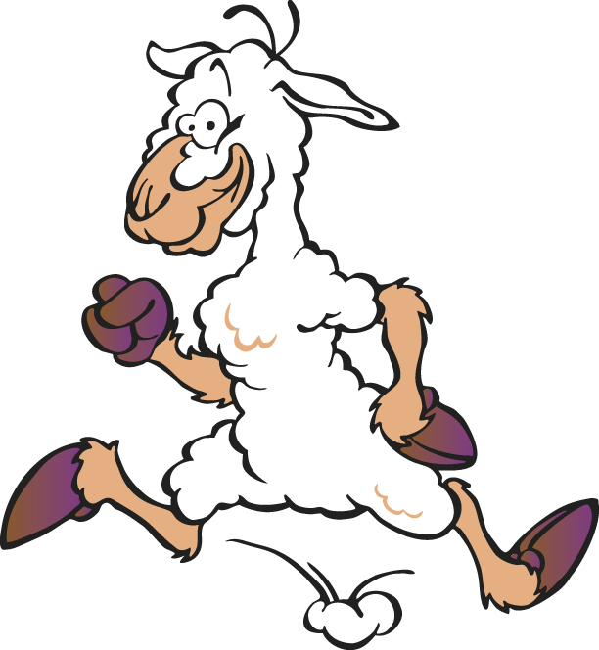

Being Safe around Sheep

Golden Rule Number One:

Always follow your tutor’s instructions fully and do not approach the sheep unless you are with your allocated supervisor.

Golden Rule Number Two:

Always Wear the Correct Clothing.

The items of clothing below should be worn when working with sheep.

Activity

Identify reasons for wearing these items:

Washable overalls
Washable, waterproof leggings
Washable, waterproof, warm jacket
Warm top
Wellington boots or strong work boots that are washable

It is likely that you will not be allowed to work with sheep while wearing jewellery or certain types of footwear.

Identify reasons why it would be unsafe to allow you to work with sheep if:

You are wearing jewellery
You are wearing trainers, sandals or high-heeled shoes

Answers

Washable overalls | Overalls are useful on dry days when it’s too hot to wear waterproof overalls.
Washable, waterproof leggings and warm jacket  Warm top | It’s often cold, damp and dirty at farmyards and so warm, waterproof and washable clothing is important.  Washable outer clothing is essential because farms may have a “biosecurity policy” where they expect you to scrub down before entering as well as after leaving the farm. This is very good practice not only from a hygiene point of view but also to help prevent disease transfer from farm to farm.
Wellington boots or strong work boots that are washable | Strong boots are necessary because it’s often muddy.

You are wearing jewellery | Jewellery can get caught on things and risk tearing of your own flesh.
You are wearing trainers, sandals or high-heeled shoes | None of these types of footwear are washable. They are also not safe on slippery farm surfaces.

Moving and Restraining Sheep

Moving Sheep

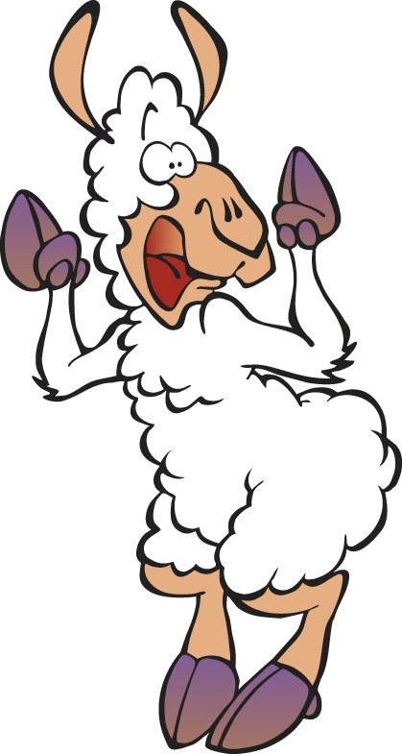Top Tips

Here are some of the basic principles:

It is important that when sheep are being moved that an appropriate route is carefully planned:

- The route that you want to drive the animals along should be obvious to the animals with gateways opened widely. If gateways are very narrow and not obvious, it may be useful to make a temporary funnel with some hurdles to help to guide them towards the area.

- Other gateways should be temporarily fenced off - people involved in moving the sheep can cover small gaps that may offer alternative escape routes.

- If surfaces are slippery, it may be necessary to put some sand down temporarily.

- It’s important to think about light and shadows: sheep will move easier into light areas and so, if sheep handling facilities are under cover, it may be a good idea to use artificial lighting.

- Sheep also tend to be better at herding up the hill rather than down.

- Make sure that any obstacles or articles that may frighten the sheep are removed from the pre-planned route.

- If animals are being moved along a public road, one person will need to go ahead of them

Move the sheep calmly and quietly:

- Try to keep them bunched together if moving towards a gateway

- Don’t let the bunch break up

- Move slowly keeping a reasonable distance from them to avoid stress

Plan your Route

Examine the map below of a sheep farm carefully. You are being asked to help to move the sheep from field number 1 to the sheep handling facility at the farm steading.

On the map use a black dotted line to identify the route that the sheep will be driven.

Use red dots to indicate where you will place people to prevent the sheep from going in the wrong direction.

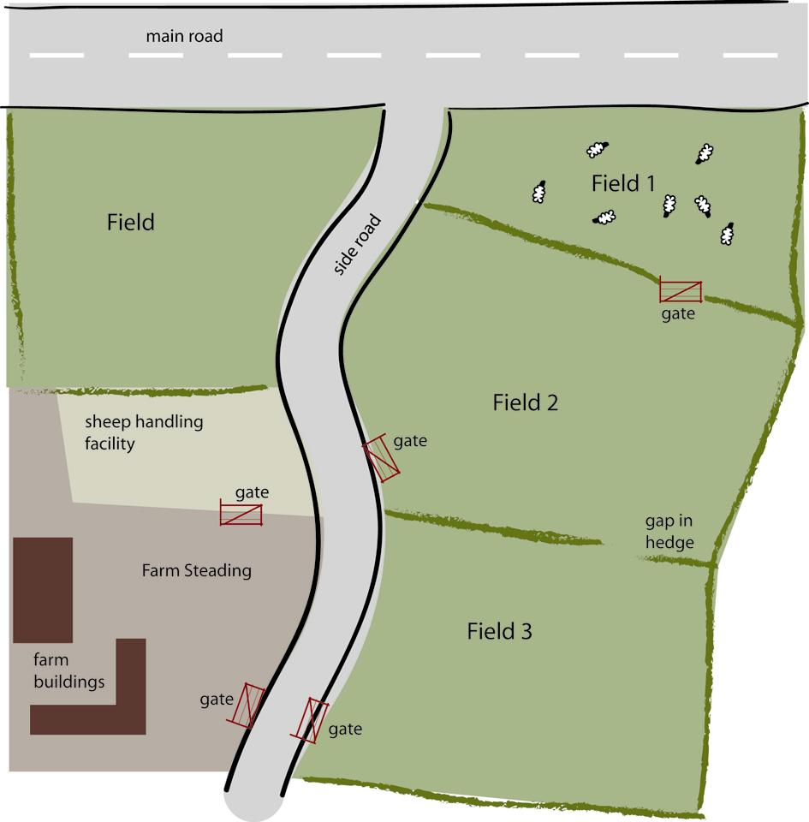
Possible Solution

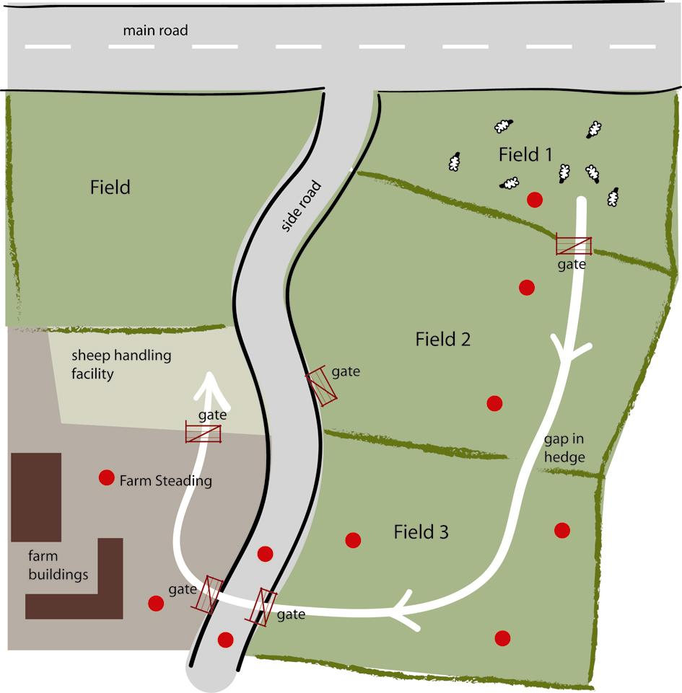

Possible Solution – Explanation

- note that you would not go for the first gate onto the side road from field 2 because the sheep would spend longer on the road

- you would need to think about how many people there were: maybe you needed to catch them in the next field and then move people to the next position?

- people on the road would not stand in the middle of the road until they were happy that the sheep were close: they would need to wear high visibility clothing

Top Tips!

- always try and anticipate or spot those sheep that look like they are going to escape before they start to run
- always think of your own safety first if a sheep tries to break away from the flock. If it’s a large sheep that you are very unsure of, move out of the way.
- sheep don’t like to be stared at so sometimes if you crouch low and hold your arms wide, flicking them, most sheep will turn back and join the rest of the flock

Identifying Sheep

Sheep can sometimes be told apart if they are different breeds or crossbreeds. However, most farms will tend to have all sheep of the same breed or cross breed and so it can be quite difficult to distinguish them from each other visually.

- sheep, by law must have an ear tag put in before they are moved off the premises or are over 9 months of age
- the farmer must keep records of all of his/her animals and record when they are moved on and off the farm

Further information on this complicated business about ear tags can be found at the following web page:

http://www.defra.gov.uk/animalh/tracing/sheep/sheepgoatsrules-idbook.pdf

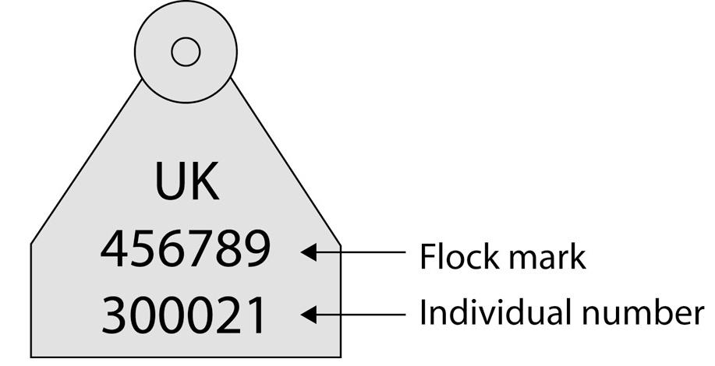

Figure 1: A sheep ear tag

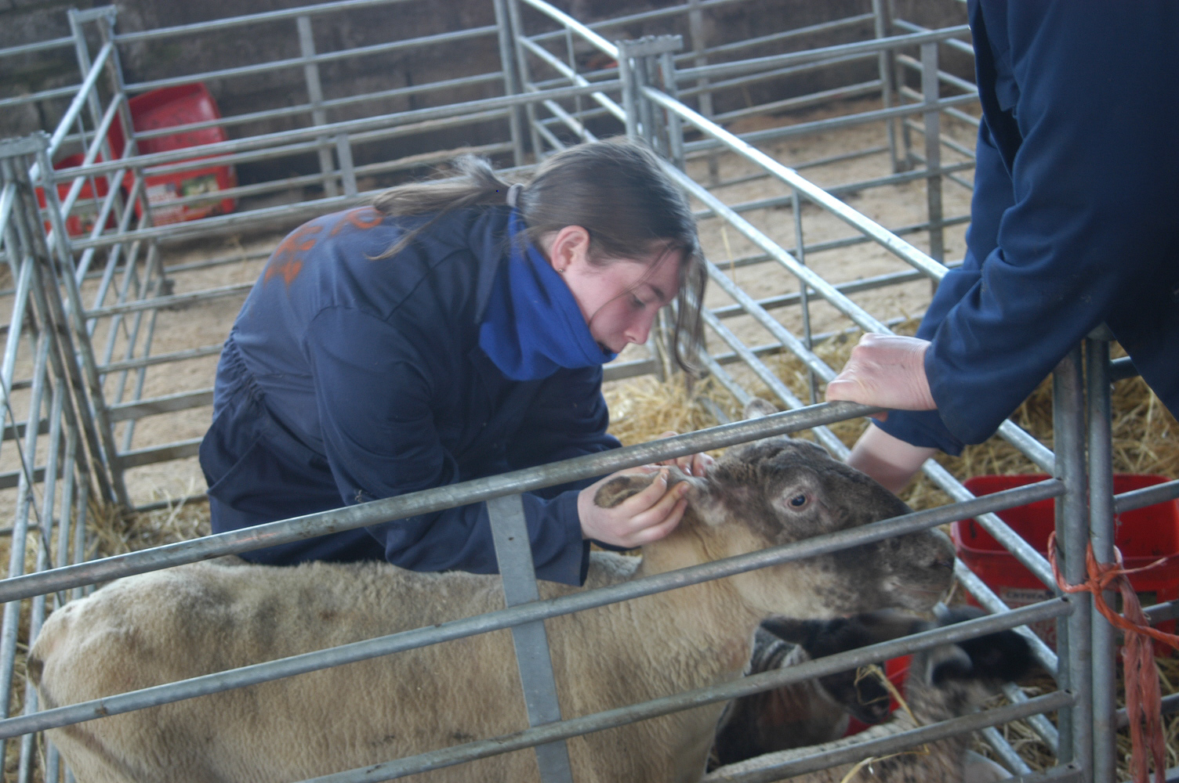

Figure 2: Reading an ear tag for identification purposes

Catching and Restraining Sheep

Like cattle, sheep are rarely trained to be lead on a halter (with the exception of show sheep). We can normally handle small lambs manually without the need for any specialist equipment. When larger sheep are being treated, it’s common for them to be handled as a flock. They are normally handled in a specialist handling system which may be either permanent or temporary. Typical handling facilities are often called sheep fanks.

They will have:

A collecting pen: a large area where all the sheep are collected together. This will need to be large enough to accommodate the whole flock

A forcing pen: this is a circular or diamond shaped area that leads on to the treatment pens or the race.

A race: this is an area that is designed to try and get the sheep into single file

A drafting/shedding gate this is a gate that can swing back and forwards to separate the sheep out

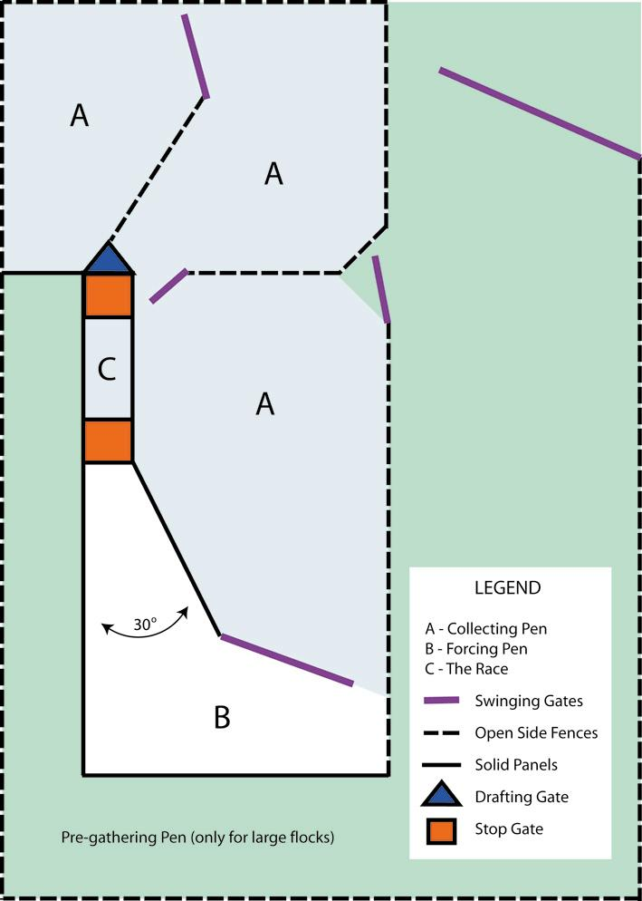

Figure 3: Diagram of a sheep handling area

Some large facilities may have a sheep turner or rollover crate: a metal crate that is designed to turn the sheep over or coup them. This is very useful for heavy sheep and tups. In other places this is done by hand.

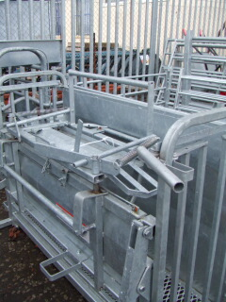

Figure 4: A sheep turner or rollover crate

Question:

Why might we want to handle lambs?

Answer

- Lambs are normally handled within the first day of birth in order to treat their navels with antiseptic spray.
- Male lambs are also often castrated within the first two days of life using a rubber ring system.
- They may be lifted to move a ewe and lamb- a ewe will follow a person carrying her lambs because the mothering instinct is very strong (sheep will not follow people at any other time!)

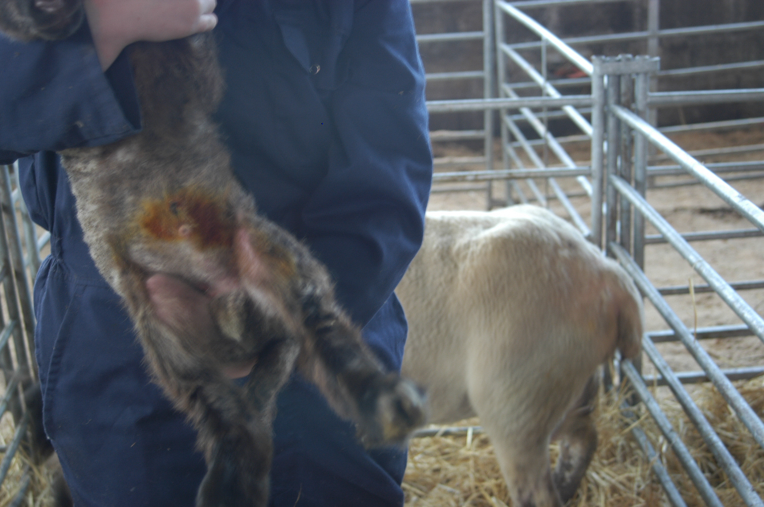

Figure 5: Lamb that has had its navel treated with antiseptic spray

Tips and Techniques for Handling Sheep

You’ll be fully instructed on the method you are expected to use in handling the animals that you have but here are some general guidelines.

Lifting a small lamb

Make sure that the lamb is lifted by both front legs and that its body weight is supported underneath.

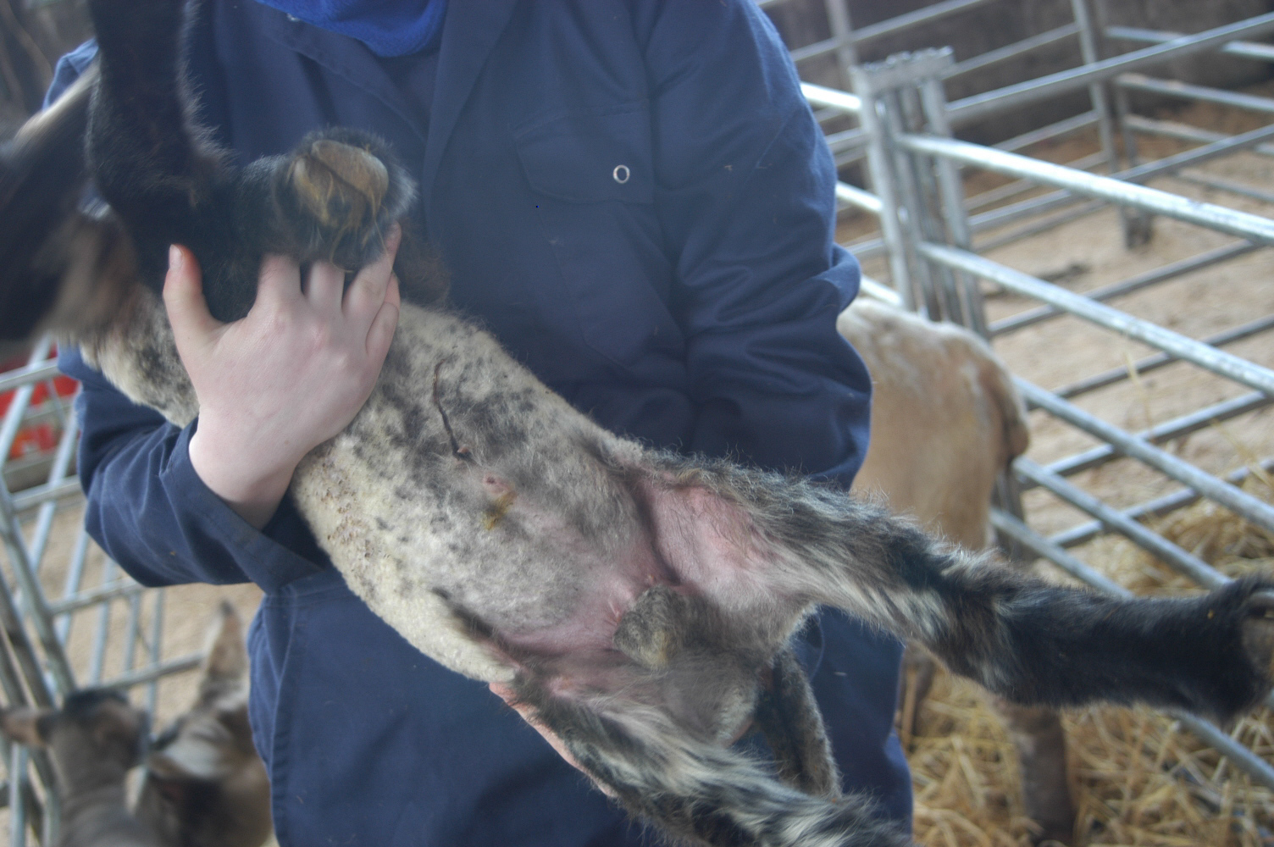

Figure 6: A small lamb being correctly lifted

Lifting a larger lamb

- Place one arm around the front end and the other around the back end.
- Make sure that you use your knees to bend down and not your back.
- Don’t release the lamb until all four legs are on the ground.
- Don’t attempt to lift a lamb that is too heavy for you to lift by yourself.

Your tutor may demonstrate this for you and allow you to practise lifting larger lambs.

Catching and holding an ewe in a standing position

Ewes may be caught using a shepherd’s crook which hooks them around the neck. This takes a lot of practice and your tutor may demonstrate the technique but you won’t have to do it on this course: the ewes need to be caught quickly and efficiently so as to minimise stress.



Figure 7: A modern shepherd's crook, used to catch individual sheep

Your tutor will also demonstrate how to catch and hold an ewe in a couped position.

Self-assessment
Now that you’ve had a chance to practise the various skills and found out more about sheep handling, you can have a go at answering the following questions:

Tick the correct box.

- Sheep are:
- hunters
- flock animals
- easy to lead
- animals that respond well to shouting
- When working with sheep, which of the following would you not consider as a serious risk?
- being bitten
- being head-butted
- being knocked over
- catching a disease due to incorrect hygiene practices
- Which of the following statements is true?
- sheep will tend to follow one another
- it is easy to separate a sheep off from the flock for treatment
- sheep prefer human company to sheep company
- sheep enjoy the company of dogs
- Which of the following pieces of equipment might you use to restrain a sheep?
- a lead and collar
- a bridle
- a crook
- a cattle crush

- What is a race in the world of sheep handling?
- when you chase the sheep to the gate that you left open
- the time limit you are given to catch a sheep
- a large pen where all the sheep collect in
- a narrow alleyway where sheep file into and can be handled
- Which of the following statements is true about sheep?
- they are easier to lead than herd from behind
- they respond well to shouting and flapping around
- they prefer going into light areas rather than dark ones
- they feel very secure when they are alone
- Which of the following methods of restraint would be suitable for a large tup that requires his feet to be inspected?
- a halter and rope alone
- a halter and rope, behind a gate or hurdle
- a sheep turner with proper leg ropes and lifting facilities
- a dog biting at the tup’s feet behind a gate
- What are hurdles?
- small jumps that sheep can practise jumping over
- machines used for shearing sheep
- foot baths
- gates that can be fitted together to make temporary sheep handling facilities

How did it go?
Check your answers against the grid.

Activity

You may also want to have a go at the PowerPoint quiz about sheep handling, located on the Skills for Work section of the SFEU website http://www.sfeu.ac.uk/

Answers

Question | Correct answer
1 | b) flock animals
2 | a) being bitten
3 | a) sheep will tend to follow one another
4 | c) a crook
5 | d) a narrow alleyway where sheep file into and can be handled
6 | c) they prefer going into light areas rather than dark ones
7 | c) a sheep turner with proper leg ropes and lifting facilities
8 | d) gates that can be fitted together to make temporary sheep handling facilities (correct answer)

Practical Activities Worksheets

This section contains practical worksheets that may be useful in getting students to reflect on what they’ve learned in practical activities.
Practical Worksheet 1

Name: ……………………………………... Date: ………………………………..

Answer the following questions about the task that you carried out today in order to move some sheep:

Question | Answer
- What type of sheep were you moving today?
- Why were they being moved?
- What sort of things did you discuss when planning to move the sheep?
- Briefly, explain the jobs/tasks that you had to do when moving the sheep.
- Were there any problems? If the answer is yes, explain briefly what happened.
- Is there anything that you would do the next time you do this that might make it easier and less stressful for the sheep?
- List any personal protective clothing and equipment that you had to use to carry out this task.
- List two safety rules that you had to follow in order to carry out this task.

Practical Worksheet 2

Name: ……………………………………... Date: ………………………………..

Answer the following questions about the task that you carried out today in order to restrain a sheep.

Question | Answer
- Briefly describe what the task was today.
- Why did the animals need to be caught or penned up?
- What type of equipment (if any) was used to restrain the animals?
- What sort of things did you discuss when planning to catch or pen up the sheep?
- Briefly, explain the tasks undertaken by you in restraining the sheep.
- Were there any problems? If the answer is yes, explain briefly what happened.
- Is there anything that you would do the next time you do this that might make it easier and less stressful for the sheep?
- List two safety rules that you had to follow in order to carry out this task.

Practical Assessment Checklist

This checklist will help you to understand what your tutor will be looking for when you’re doing the practical assessments in this Unit. Use this checklist to think about whether you are doing all these things when you are practising for the assessment tasks and to work out what you need to improve on.

Can I: | Yes/No | Things I need to work on or get help with
- help to move a group of sheep e.g. from a field to a handling facility
- show the tutor that I understand how sheep are likely to behave when being handled and moved
- help to catch a sheep
- help to hold a sheep steady for examination (this could be a couped sheep or held against a wall)
- carry out all of these tasks safely

Further Revision

Complete the blanks:

Moving Sheep

It is always easier to move a group of sheep rather than a single one because of their very strong (1) _____________ instinct. Sometimes a farmer may only want to catch a single ewe or lamb in a handling facility in order to treat it but will take it with a few others to that facility because this tends to keep the animal (2) _______ and less likely to panic and become quite so stressed.

If you flap your arms around wildly, shouting, it will (3) _____________ the sheep a great deal. This will tend to make them panic and scatter all over the place (just like one of those wildlife films where antelope are being chased by lions). It is not unknown for sheep to literally drop (4)_____________ because of such stress so it is very important that this does not happen.

It is important that the movement of sheep is carefully (5)________________ and that the correct gates are opened and any escape routes are covered either by people or by putting up temporary fences made of hurdles.

Choose from these words: calm dead flock planned stress

Solution

Moving Sheep

It is always easier to move a group of sheep rather than a single one because of their very strong flock instinct. Sometimes a farmer may only want to catch a single ewe or lamb in a handling facility in order to treat it but will take it with a few others to that facility because this tends to keep the animal calm and less likely to panic and become quite so stressed.

If you flap your arms around wildly, shouting, it will stress the sheep a great deal. This will tend to make them panic and scatter all over the place (just like one of those wildlife films where antelope are being chased by lions). It is not unknown for sheep to literally drop dead because of such stress so it is very important that this does not happen.

It is important that the movement of sheep is carefully planned and that the correct gates are opened and any escape routes are covered either by people or by putting up temporary fences made of hurdles.

Glossary of Terms

Biosecurity | Biosecurity is the term used to describe the measures taken by a farm to prevent the transfer of disease on and off the premises. This is a very important consideration for any farm that is moving livestock about.
Blind Spot | a small area directly behind a sheep that it can’t see: a good place to be when trying to catch a single sheep
Collecting Pen | a large penned off area that can hold all (or nearly all) of the flock
Coup/couped | This is the turning of a sheep on to its bottom, with it leaning against you. This is a common way to hold sheep in order to examine their feet and to shear them.  It can also mean a sheep that is lying on its back and unable to get up.
Crook | a long pole that has a hooked end for catching sheep with
Drafting/shedding gate | this is a gate that can swing in two directions and fix to either side; it is used to split up sheep in handling facilities
Ear tag | this is a small plastic or metal tag which is attached to a sheep’s ear by piercing; all sheep must be tagged before they leave their birthplace by law
Ewe | an adult female sheep
Flock/  flock behaviour/ Herd instinct | the instinct of sheep to move around together as a large group called a flock rather than a herd (as it is with sheep); they have a strong desire to follow each other
Footbath | Sheep often suffer from lameness because of ‘foot rot’. Footbaths contain chemicals that help to prevent and treat foot rot. The sheep run through the chemicals in the race.
Forcing Pen/  Funnel | A circular or diamond shaped area that leads on to a narrower area. It is used to ‘funnel’ the sheep in to a narrow area.
Hurdle | This is a small gate that is put up temporarily by farmers. It can be easily attached to other ‘hurdles’ to provide temporary penning off of an area.
Lamb | a young sheep
Prey animals | animals that are likely to be eaten by other meat eating animals
Race | a long enclosed alleyway; for sheep, a footbath may be placed within the race or it may lead up to individual handling facilities
Restrain/restraining | to restrain means to hold still or prevent movement; it does not mean that the animal is being pinned down in this sense of the word
Shear/shearing | shearing is the act of removing the sheeps’ fleeces which is done by clipping in the early summer to stop them from over-heating
Sheep Dip/Dipping | Sheep are very prone to developing skin parasites. They are often dipped in a chemical bath, usually in the autumn to get rid of parasites and to help to prevent them. They may also undergo cosmetic dipping before the sheep sales.
Sheep Turner/Rollover crate | This is a special metal crate designed for flipping sheep over with. Sheep need to be flipped if they need their feet trimmed. They also tend to stay much stiller when flipped.
Tup | an adult male sheep that still has his testicles

