Skills for Work

Rural Skills: Animal Husbandry: An Introduction (Sheep)

(Intermediate 1)

Support Material

July 2006

Scottish Further Education Unit

Acknowledgements

SFEU is grateful to the subject specialists in Scotland’s Colleges and other agencies and industry bodies who have been involved in the writing of this and other support materials in the Skills for Work series.

SFEU is also grateful for the contribution of the Scottish Qualifications Authority in the compilation of these materials, specifically for its permission to reproduce extracts from Course and Unit Specifications and the Skills for Work Rationale, and to LANTRA for help and advice.

Clip art in this pack is reproduced by kind permission of Bayer Healthcare, Animal Health Division, Bayer House, Strawberry Hill, Newbury, Berkshire, RG14 1JA.

© Scottish Further Education Unit 2006
Rural Skills: Animal Husbandry: An Introduction (Sheep), Intermediate 1

DX0X 10

Introduction

These notes are provided to support teachers and lecturers presenting the Scottish Qualifications Authority Unit DX0X 10 Rural Skills: Animal Husbandry: an Introduction (Sheep context). Copyright for this pack is held by the Scottish Further Education Unit (SFEU). However, teachers and lecturers have permission to use the pack and reproduce items from the pack provided that this is to support teaching and learning processes and that no profit is made from such use. If reproduced in part, the source should be acknowledged.

Enquiries relating to this Support Pack or issues relating to copyright should be addressed to:

Marketing Officer - Communications
The Scottish Further Education Unit
Argyll Court
Castle Business Park
Stirling
FK9 4TY

Website: www.sfeu.ac.uk

Further information regarding this Unit including Unit Specification, National Assessment Bank materials, Centre Approval and certification can be obtained from:

The Scottish Qualifications Authority
Optima Building
58 Robertson Street
Glasgow
G2 8DQ

Website: www.sqa.org.uk

Whilst every effort has been made to ensure the accuracy of this Support Pack, teachers and lecturers should satisfy themselves that the information passed to candidates is accurate and in accordance with the current SQA arrangements documents. SFEU will accept no responsibility for any consequences deriving either directly or indirectly from the use of this Pack.
Contents

Reference Section 7
What are Skills for Work Courses all about? 8
The Course in Rural Skills (Intermediate 1) 11
Unit Outcomes, PCs and Evidence Requirements 13
Employability Skills Profile 16
Tutor Support Section 17
How to use this pack 18
Guidance on Delivery of Animal Husbandry: An Introduction (Sheep) 20
Employability Skills 23
Integrating the Content of the Employability Skills Unit and other generic employability skills 23
Generating Evidence and Assessment Opportunities for Employability Skills 25
Resources 27
Learning and Teaching with Under 16s 31
Skills for Work Workshops 34
Student Support Section 35
Welcome to Animal Husbandry (Sheep) 36
Sheep Husbandry 37
Basic Characteristics of Sheep 41
How to tell Male from Female Sheep 45
Signs of Health 48
Preparing Sheep Accommodation and Mucking Out 56
Bedding 58
Feeding and Watering Sheep 61
Practical Activities Worksheets 72
Practical Assessment Checklist 78
Further Revision 79
Glossary of Terms 82

Reference Section

What are Skills for Work Courses all about?

Skills for Work Courses are designed to help candidates to develop:
- skills and knowledge in a broad vocational area
- Core Skills
- an understanding of the workplace
- positive attitudes to learning
- skills and attitudes for employability

A key feature of these Courses is the emphasis on experiential learning. This means learning through practical experience and learning by reflecting on experience.

Learning through practical experience

Teaching/learning programmes should include some or all of the following:
- learning in real or simulated workplace settings
- learning through role play activities in vocational contexts
- carrying out case study work
- planning and carrying out practical tasks and assignments

Learning through reflecting at all stages of the experience

Teaching/learning programmes should include some or all of the following:
- preparing and planning for the experience
- taking stock throughout the experience
- reviewing and adapting as necessary
- reflecting after the activity has been completed
- evaluating, self-assessing and identifying learning points

The Skills for Work Courses are also designed to provide candidates with opportunities for developing Core Skills and enhancing skills and attitudes for employability.

Core Skills

The five Core Skills are:
- Communication
- Numeracy
- Information Technology
- Problem Solving
- Working with Others

Opportunities to develop aspects of Core Skills are highlighted in Guidance on Teaching and Learning Approaches.

Employability

The skills and attitudes for employability, including self-employment, are outlined below:
- generic skills/attitudes valued by employers
  - understanding of the workplace and the employee’s responsibilities, for example time-keeping, appearance, customer care
  - self-evaluation skills
  - positive attitude to learning
  - flexible approaches to solving problems
  - adaptability and positive attitude to change
  - confidence to set goals, reflect and learn from experience

- specific vocational skills/knowledge
  - Course Specifications highlight the links to National Occupational Standards in the vocational area and identify progression opportunities

Opportunities for developing these skills and attitudes are highlighted in each of the Course and Unit Specifications. These opportunities include giving young people direct access to workplace experiences or, through partnership arrangements, providing different learning environments and experiences which simulate aspects of the workplace. These experiences might include visits, visiting speakers, role play and other practical activities.

A Curriculum for Excellence (Scottish Executive 2004) identifies aspirations for every young person. These are that they should become:
- successful learners
- confident individuals
- responsible citizens
- effective contributors

The learning environments, the focus on experiential learning and the opportunities to develop employability and Core Skills in these Courses contribute to meeting these aspirations.

The Course in Rural Skills (Intermediate 1)

Course Rationale

The land-based sector is very diverse and includes a wide number of disciplines that share a common element of being active, practical and mainly based outdoors. The major disciplines that are recognised as land-based by the sector skills council for the area include the following: agricultural crops; fencing industries; land-based engineering industries; production horticulture industries; tree and timber related industries; environmental conservation industries; landscaping industries; agricultural livestock; animal care industries; aquaculture; equine industries; farriery; fisheries management; game and wildlife management and veterinary industries.

There is a very wide range of land-based businesses in Scotland with a great variety of job roles. Changes in rural land use, including the decline and change of traditional agriculture, have created a knowledge gap. Research has indicated that fewer people are likely to contribute to the rural economy and its development unless more individuals are introduced to the possible opportunities in land-based industries in the UK.

This Rural Skills Course has been designed to provide a broad basis for progression into further education and training in the land-based sector. It allows candidates to begin to develop some of the basic practical skills necessary to work in most of these disciplines as well as an opportunity to explore the very diverse employment prospects that exist.

The primary target group for the course is school candidates in S3 and S4. It is anticipated that, for this group of candidates, the course will rely on and build on existing partnerships between schools and further education colleges delivering specialisms in land-based industries. It may also be delivered in conjunction with training providers or employers specialising in the land-based industries. These partnerships will enable the course to be delivered in a variety of appropriate learning environments with access to relevant teaching expertise.

The course has been designed with a common core that allows candidates to develop an insight into the numerousopportunities for the land-based industries and to develop the basic common skills of the sector. It also allows candidates to choose a route that is related to either animals or plants where they can develop specific basic practical skills in that general category.

The general aims of the course are to:

- widen participation in vocationally-related learning for 14–16 year olds

- allow candidates to experience vocationally-related learning

- provide candidates with a broad introduction to the land-based sector

- encourage candidates to develop a good work ethic including reliability, flexibility and a positive attitude to work

- provide opportunities to develop Core Skills in a realistic context

- encourage candidates to take charge of their own learning and development

- provide a range of teaching, learning and assessment styles to motivate candidates to achieve their full potential

- facilitate progression to further education and/or training

The specific aims of this course are to:

- introduce candidates to the various disciplines of the land-based sector

- allow candidates to develop a basic knowledge of a selection of land-based industries and related job roles

- allow candidates to experience an outdoor working environment

- allow candidates to develop an understanding of the very flexible requirements of the individual who works with plants and/or animals

- allow candidates to develop an awareness of health and safety issues that are integral to a career in a land-based industry

- allow candidates to develop the technical knowledge, skills and understanding of some of the commonly used practical skills associated with land-based industries at this level

- introduce candidates to the technical knowledge, skills and understanding of some specific practical skills associated with a selection of land-based industries at this level

- prepare candidates for more focused further learning opportunities, study and training for employment in land-based industries

Unit Outcomes, PCs and Evidence Requirements

Unit Specification: statement of standards

Unit: Animal Husbandry: An Introduction (Intermediate 1)

Acceptable performance in this Unit will be the satisfactory achievement of the standards set out in this part of the Unit specification. All sections of the statement of standards are mandatory and cannot be altered without reference to the Scottish Qualifications Authority.

Outcome 1

Identify basic characteristics of animals.

Performance Criteria

- Correctly identify gender differences of animals.
- Correctly identify signs of health of animals.
- Correctly identify the breed of animals.
- Correctly identify the life stage of animals.

Outcome 2

Assist with the preparation and maintenance of accommodation for animals.

Performance Criteria

- Assist in setting up animal accommodation.
- Assist in cleaning animal accommodation.
- Demonstrate safe working practices.

Outcome 3

Assist with the preparation and provision of food and water for animals

Performance Criteria

- Assist in the preparation of appropriate food for animals, following instructions.
- Assist in the provision of food for animals.
- Provide water in an appropriate manner for animals.
- Demonstrate safe working practices.
Evidence Requirements For This Unit

Performance evidence supported by an assessor observation checklist is required to show that all Outcomes and Performance Criteria have been achieved.

Evidence must be gathered in an appropriate context where live animals are kept in work settings or simulated work settings.

For each Outcome, evidence is required in relation to one category of animal. The animal(s) can be selected from the following:

- horses
- sheep
- cattle
- pigs
- game birds
- small ‘cage’ companion mammals
- domestic dogs
- domestic cats

The first section of the assessor observation checklist confirms that the candidate has identified:

- two physical characteristics that allow gender identification
- five signs of good health
- two breeds of the same category of animal (photographic identification is acceptable)
- two life stages selected from young, adolescent, adult, old, pregnant, lactating (photographic identification is acceptable)

The second section of the assessor observation checklist confirms that the candidate has assisted in:

- setting up accommodation for the animal(s)
- cleaning the accommodation for the animal(s)
- preparing food for the animals
- providing food for the animals
- providing water in an appropriate manner for the animals
The item for this Unit contains assessor observation checklists. The NAB illustrates the national standard required for this Unit. Centres who wish to devise their own assessments should refer to the NAB to ensure a comparable standard.

NB Centres must refer to the full Unit Specification for detailed information related to this Unit.

Employability Skills Profile

Employability Skills Profile: Rural Skills (Intermediate 1) | = A | = B | = C | = D | = E | = F | = G |  | In addition to the specific, vocational skills developed and assessed in this Course, employability skills are addressed as detailed below: | Evidence | C | A | A, C | A, C, D, E, F, G | C | A,B,C, D, E, F, G | B, C, D, E, F, G | A, C | C |  | Assessment evidence: | A = Portfolio containing candidate planning and review sheets and assessor checklists | B = Assessor checklists of practical tasks undertaken | C = Candidate/assessor review sheets, risk examination log | D = Assessor checklists and candidate log sheets of practical tasks undertaken | E = Assessor checklists and candidate log sheets of practical tasks undertaken | F = Assessor checklists and candidate log sheets of practical tasks undertaken | G = Assessor checklists and candidate log sheets of practical tasks undertaken
Employability Skills Profile: Rural Skills (Intermediate 1) | Land Based Industries: An Introduction | Estate Maintenance: An Introduction | Employability Skills for land based industries | Animal Husbandry: An Introduction | Animal Handling: An Introduction | Crop Production: An Introduction | Soft Landscaping: An Introduction |  |  | Employability skill/attitude | - acceptable time keeping and attendance | - understanding roles and responsibilities in the workplace | - planning and preparing for work | - working co-operatively with others | - awareness of efficient resource use | - ability to follow instructions | - health and safety awareness | - self review and evaluation | - positive attitude to learning

Tutor Support Section

How to use this pack

This pack comes in two sections.

In the first section advice is given to tutors on the following:
- general Guidance on delivery specifically in the context of sheep
- signposting of Employability Skills as they occur within the Unit
- guidance on Integrating the Employability Skills for Land-based Industries Unit as well as generic employability skills, qualities and attitudes throughout the Unit
- advice on where it would be appropriate to collect evidence for the assessment of employability skills)
- resource requirements in terms of physical resources and recommended texts or supplementary resources
- a suggested learning programme
- guidance on Learning and Teaching with under 16s

In the second section, student support notes are provided which include the following:
- a general introduction to the content and format of the Unit
- materials relating to the knowledge, understanding and practical skills of the Unit.
- some interactive student activities accompanied by exemplar answers for student referral or tutor use following activity
- some self evaluation/reflection tasks following activities as appropriate
- some worksheets that may support practical activities
- guidance on likely practical activities that the student will be assessed on
- a self-assessment area for students to test their own knowledge and understanding (for use when student is familiar with both all of the practical and knowledge aspects of the Unit)
- revision activities
- a glossary of topic specific terminology for student referral

Tutors should note that this is not designed as a complete teaching pack. The student notes are intended to support the teaching process, give guidance as to the level of knowledge and understanding that is expected and give the student opportunity to reinforce and self-review what they have learnt. They are not designed to be a substitute for practical activity but are a useful adjunct to it. Use of the materials and activities is not mandatory but they will provide centres with a flexible set of materials which can be selected, adapted and used in an order that best suits their situation. Tutors are encouraged to use the materials creatively in ways which will engage the younger student.

You may wish to place the student notes on your own Intranet by downloading this pack from the Skills for Work section of the SFEU website www.sfeu.ac.uk. The hyperlinks are live and there is also a link between emboldened terms to the Glossary of terms, which may be useful for the learner.

If printing out the student notes, please note that the photographs should be in colour (e.g. to help with breed identification).

The use of textbooks is only appropriate as an introduction to working with sheep.
Activities are identified with the symbol.

Guidance on Delivery of Animal Husbandry: An Introduction (Sheep)

It is important that the majority of learning activity takes place involving live cattle in either a work setting or simulated work setting. Partnerships with land-based colleges, training providers or employers are likely to provide the most appropriate settings. Students should experience the proximity of sheep, the outdoor working conditions and the associated effects on their senses (smells, dirt, and ambient temperatures).

Students must be under direct supervision at all times when carrying out the practical activities of this Unit.

It is important that the deployment of appropriate learning environments is preceded by a valid risk assessment by the Centre, particularly identifying any protective clothing and equipment (PPE) that the student may require and any regulations applying to work with sheep. Students must be supplied with correctly fitting PPE prior to the undertaking of any of the practical activity.

Centres delivering this learning programme in the context of sheep should pay particular attention to the risk assessment of sizes of student groups in relation to the number of supervisors available. A maximum group size of 8 students per supervisor is recommended.

The Health and Safety Executive (HSE) have a publication called “Your Essential Guide to Health and Safety in Agriculture” which gives comprehensive information about the health and safety aspects of working in agriculture. This can be downloaded from the following HSE website: http://www.hse.gov.uk/pubns/misc165.pdf.

Particular consideration should be given to the risks of sheep dip on the farm and the zoonotic risk for young people of ewes at lambing time.

The HSE also provide a free download publication that allows farms to carry out their own self assessment. This can be found at the following address:

http://www.hse.gov.uk/agriculture/assessment/download.htm

Sheep husbandry routines that are undertaken or referred to should all fall within the Code of Recommendations for the Welfare of Livestock: Sheep. This document can be downloaded from the Scottish Executive website:
http://www.scotland.gov.uk/Publications/2005/07/18142335/23383

It is important that the delivery centre is aware that there may be some seasonal and situational restrictions regarding the housing and feeding of sheep. Production systems where lambing occurs outdoors will make teaching and assessment of Outcome 2 difficult (preparing and cleaning accommodation). It may be useful to think about teaching and assessing this in the context of cattle or another species if this is the case. If indoor lambing does occur at the delivery site, then consideration needs to be given to the timing of delivery of Outcome 2 and 3. Lambing time for housed sheep can be at any time between January and April. The delivery centre would need to plan with the site as to the appropriate time for delivery.

Students should gain an understanding in particular of the sheep that they are being asked to work with. The number of sheep kept should be sufficient to allow students to be involved with at least ten or twelve different animals and to gain real experience of sheep husbandry routines.

In relation to Outcome 1 of the Unit:

For gender (sex) identification, students should be shown where to look for differences in gender under the tail. They should also learn to identify the udder of the ewe and the sheath of wedders and tups. They should be able to identify where testicles would be situated in a tup and to point them out on a tup if one is available. They should not be expected to handle the tup to do this.

Opportunities for examining animals for health can be taken on a walk around the farmyard or even a field of quiet animals.

As many sheep holdings do not have a variety of breeds, it may be useful for students to become acquainted with common sheep breeds and commercial crosses using photographic material. Only common sheep breeds should be examined. However, if the delivery Centre happens to have an unusual breed of sheep, it would be acceptable for students to become familiar with that breed too.

The identification of life stage in sheep is likely to lead to some discussion of different production systems and it would be helpful to discuss the particular production system that the animals worked with are in. This should not be detailed, but should help to put the learning experience in context.

In relation to Outcomes 2 and 3 of the Unit:

Students should be allowed to assist manual operations wherever possible but it would also be very advantageous for them to observe some of the mechanical operations in action where this occurs. The learning process should be about involving them in the real husbandry procedures that occur on that particular sheep holding. If procedures are less mechanical (such as on a croft), the student involvement is likely to be greater.

It would be useful for all three of the Outcomes to have some classroom theoretical and interactive input prior to undertaking some of the practical activities. In Outcome 1, initial classroom activities introducing the category of animal, how to recognise gender, appropriate nomenclature for genders and age groups, signs of health, breeds, types and life stages relevant to sheep would all be helpful. However, it is important to stress the level of this award and it is not appropriate to examine in detail any of these aspects. Classroom activity should be as interactive as possible and the activities in the student support notes may be useful additions to the experiential learning process.

Employability Skills
Signposting of Employability Skills in the Animal Husbandry:
An Introduction (Sheep) Unit

Throughout the unit students will have the opportunity to develop the following employability skills. Where opportunities to integrate and embed these through the activities suggested in this pack, they are highlighted with a numbered flag as shown above. The numbers corresponding to each employability skill are:

1 | Timekeeping and attendance | 4 | Working cooperatively with others | 7 | Health and safety awareness*
2 | Understanding roles and responsibilities in the workplace | 5 | Awareness of efficient resource use | 8 | Review and self evaluation
3 | Planning and preparing for work | 6 | Following Instructions* | 9 | Positive attitude to learning

Achievement in employability skills marked with an asterisk* will be clearly identified as a result of the evidence generated through the assessment activities for this Unit. There are opportunities in the Unit to develop the remaining skills identified, particularly if learning activity encompasses the following recommendations.

Integrating the Content of the Employability Skills Unit and other generic employability skills

It is important to adopt a delivery approach of emphasising not only the vocational skills development but also the development of employability skills and attitudes in this Unit. This could be done by:

- setting particular start times for practical activities
- monitoring the students’ ability to follow instructions
- setting incremental targets for students in terms of mock deadlines for given practical activities (once they have developed reasonable competence)
- monitoring the preparation and planning of the students for practical activities
- setting students a task as a group and allowing them to be responsible for the allocation of subsets of tasks to encourage team working
- encouraging students to reflect on their own and group performance regularly
- monitoring the safety awareness of the learners when carrying out tasks
In relation to Animal Husbandry (Sheep): An Introduction, the following examples of learning activity may be appropriate. (Note that some of these activities require the student to have developed some familiarity with the vocational task and the work setting):
- Set a time target on a task that they have practised such as feeding a group of sheep or preparing substitute milk to feed to a lamb.

- Set a specific time when students are to be prepared for a given work activity, wearing the appropriate PPE and armed with the appropriate tools or aids.

- Instruct a group of students on an overall activity such as mucking out a lambing pen and allow the group to distribute related activities amongst themselves.

- Students could discuss the hazards for the tasks that they are about to undertake and how they can be minimised.

- Students could be encouraged to participate in self and peer review and evaluation of tasks undertaken. As much of the activity in this course is practical, group-related and hands-on, it fits well with this simple review model.

Generating Evidence and Assessment Opportunities for Employability Skills

In addition to developing the student’s employability skills throughout the delivery of the Unit, there are specific opportunities to generate evidence for assessment of employability skills. You should refer to the employability skills profile in the reference section at the front of this pack to familiarise yourself with these skills. You should also familiarise yourself with the National Assessment Bank (NAB) material for the Employability Unit.

There are opportunities to complete all parts the review sheets of the Employability Skills for Land-based Industries Unit (Outcomes 1 and 2) when carrying out tasks related to Outcome 2 and 3 of this Unit (feeding and cleaning animals). If course teams choose to adopt this method of assessment they should consider the following:

- Design the activity in a manner that will make it clear to the students that they have been given the opportunity to demonstrate all of the employability skills by beginning with a short briefing.
- Pay particular attention to the inclusion of awareness of efficient use of resources: choose an activity where the student has to, for example, place fresh straw in the pen or muck out a pen.

Example

“Today we are going to work in small groups and muck out these lambing pens. You must:

- form groups
- decide what tools are required
- decide who is doing what between yourselves
- carry out your part of the activity
- tidy up after yourselves
- report back to [the tutor] when completed
- return to [the classroom] and complete section 1 of the review sheet and bring it to [the tutor] for their section to be completed

You’ll be assisted with tasks when required and you can ask for help whenever you need it.”

Students should be briefed, prior to commencement of a planned task, that they will be assessed on the main employability skills identified in the review sheet which are:

- acceptable time keeping and attendance
- planning and preparing for work
- working co-operatively with others
- awareness of efficient resource use
- following instructions
- working safely

The students can then be briefed on the second section of the review sheet (strengths, weaknesses and action plan). They should then be asked to complete this prior to the next session planned with the tutor.

Almost all of the practical activities involved in the delivery of this Unit give the student the opportunity to complete the assessment of Outcome 3 of the Employability for Land-based Industries Unit.

Carrying out simple risk assessment prior to practical activities is an excellent way to raise student safety awareness of tasks that they are about to undertake as suggested above and could become a regular feature of the delivery of all practical activity in this Unit. This would make the formal assessment activity familiar to the student, allowing several opportunities to complete the pro-forma assessment for Outcome 3 of the Employability Unit.

Resources

Resource Requirements for Animal Husbandry: An Introduction (Sheep)

Physical Resources:
- classroom or workroom facilities to deliver theory aspects of the course: should include presentation facility, whiteboard or flipcharts
- access to a site or sites where a group of cattle (either dairy or beef) are kept in a work setting or simulated work setting; (this should ideally be a working farm, croft or land-based college)
- there must be suitable and safe housing facilities for the cattle in accordance with the Code of recommendations for the welfare of livestock: sheep.
Personal Protective Clothing and Equipment (PPE):

Centres should provide PPE for all students as deemed necessary in accordance with risk assessment of tasks to be undertaken. This is likely to include the following items:

- strong Wellingtons or other washable footwear
- overalls or warm, washable clothing
- waterproof jacket (of a standard that will not deteriorate on contact with disinfectants)
- waterproof over-trousers (of a standard that will not deteriorate on contact with disinfectants)
Recommended Supplementary Learning Resources

The following website of the National Sheep Association has some excellent background information about the UK sheep industry as a whole:

http://www.nationalsheep.org.uk/pages/newframeset.htm

The following websites have some useful information about sheep husbandry and agriculture in general:
http://www.scotland.gov.uk/Topics/Agriculture up to date information about agriculture in general
www.ukagriculture.com/ interesting information and news about agriculture in general
www.aboutscotland.com/jedforest/ a farm with livestock near Jedburgh Scotland that does farm visits
www.nfu.org.uk this website and the section about agriculture has some excellent information about working in farming

http://www.soilassociation.org/web/sa/saweb.nsf/manuf/secondary.html this website has some useful introductory resources about farming in general

The following book may be useful for the tutor but goes further than the level of this Unit:

A basic introductory manual to keeping sheep:
Kim Cardell “Practical Sheep Keeping” Crowood Press

- There are some Practical Activities Worksheets towards the end of the Student Support Section that may be of use to tutors to help consolidate practical learning carried out.

- There are additional quizzes to be found on the SFEU website www.sfeu.ac.uk. You may wish to download these and place them on your own Intranet for easy access.

Suggested Learning Programme for Animal Husbandry: An Introduction (Sheep) Unit

Chunks of learning activity are suggested for this Unit. The order, grouping and timing of these sessions are at the discretion of individual centres and will depend on factors such as timetabling, class size etc. Classroom activities may be best grouped together and carried out before the practical activity. However, the emphasis is on practical experiential learning and not on didactic delivery of information and most of the allocated time should be dedicated to demonstration of correct practice with the students’ involvement in assisting with daily husbandry routines. It may be appropriate to mix some of these activities with those found in the Animal Handling: an Introduction Unit.

All practical activities should be preceded by an inspection of students to ensure the correct fitting of PPE.

It would be useful to familiarise yourself with the content of the student support material. Some of the written exercises and notes can be used to enhance classroom–based introductory sessions including the re-enforcement of working safely. Some of the later exercises can be used to help students to self-review their practical activities. The self-assessment and revision sections are for use only once the student has a full understanding of the entire content of the course.

The following chunks may be appropriate:

Class Based Activity – 8 hours max  The classroom sessions are designed to be short and interactive and they may be grouped together. | Practical Activity – 32 hours minimum  Practical worksheets to support tasks are included in the Student Support section.
- introduction to animal husbandry: classroom activity  - being employed to work with sheep: classroom activity  - introduction to sheep: classroom activity  - common terminology: classroom activity  - distinguishing between male and female sheep: short classroom activity  - signs of health: interactive activity and feedback: short classroom activity  - recognising health: short classroom or activity  - breeds and cross-breeds of sheep: a short classroom session  - life stages: a classroom session  - safety induction for working on the sheep holding: a classroom activity | - practical sessions on examining various sheep to identify gender, health, breeds, life stages (Practical worksheet 1 in Student Support section)  - practical session introducing types of sheep housing, bedding material, tools and rules of the sheep holding (Practical worksheet 2 in Student Support section)  - practical session demonstrating correct technique for bedding out sheep pens  - group discussion on hazards associated with bedding out and how to minimise the risk of these  - set practical sessions for groups to help bedding given a generous timeframe (this could incorporate first review sheet of employability unit)  A minimum  Of 32 hours  Practical  activity  - group/peer review of performance at bedding out (Practical worksheet 3)  - set practical session for groups to help muck out given a slightly tighter timeframe  - repeat above practical sessions to ensure competence (this could incorporate second review sheet of employability unit)  - practical session introducing types of food, tools for feeding and rules for feeding.  - group discussion on hazards associated with feeding sheep and how to minimise the risk of these  - practical sessions of preparing feed and water under instruction and supervision. (Practical worksheet 4)  - practical sessions of providing feed and water under instruction and supervision (this could incorporate third review sheet of employability unit)  - summative assessment session for each Outcome when learner ready for assessment.

Learning and Teaching with Under 16s

Scotland’s Colleges have made significant progress in meeting the needs of young learners. Our knowledge of the learning process has increased significantly and provides a range of strategies and approaches which gives us a clear steer on how lecturers can add to their skill repertoire. Lecturers can, and do, provide a stable learning environment where young students develop a sense of self-respect, learn from appropriate role models and see an opportunity to progress. There are basic enabling skills for practical application which can further develop the learning process for this group of students. So what are the characteristics of effective learning and teaching which will help to engage young learners?

Ten ways to improve the learning process for Under 16s
(This list is not exhaustive!)

- Activate prior knowledge and learning – ascertain what the learner knows already and teach accordingly. Young people do have life experience but it is more limited than adult learners and they may not always be aware of how it will assist them in their current learning.
Tips - Question and answer; Quick Quiz; Quick diagnostic assessment on computer; present key words from the course or unit and see how many they recognise or know something about.
- Tune learners into the Big Picture – the lecturer knows the curriculum inside out and why each lesson follows a sequence, however the young learner does not have this information and is re-assured by being given the Big Picture.
Tips – Mind map or concept map; use visuals, for example wall displays of diagrams, photographs, flow charts; explain the learning outcomes in language they will understand; We Are Learning Today (WALT) targets and What I‘m Looking For (WILF) targets; give clear and visible success criteria for tasks.
- Use Advance Organisers – these are lists of the key concept words that are part of the course or unit.
Tip – Highlight on any text the concept words that you will be using; make a visible list and put it on display – concept words can be struck off or referred to as they occur (NB this helps with spelling and independent learning as they do not have to keep checking meaning); highlight essential learning and action points.
- Vary the teaching approaches. The two main approaches are instructing and demonstrating, however try to provide opportunities to facilitate learning.
Tips – Ask students what they know now that they did not know before, or what they can do now they could not do before, at appropriate points in the lesson or teaching block; ensure there are problem solving activities that can be done individually or in groups; ask students to demonstrate what they have learned; use a range of question and answer techniques that allow participation and dialogue, eg. provide hints and cues so that they can arrive at answers themselves.
- Preview and review of learning. This helps to embed previous learning and listening skills and provides another opportunity to elicit learner understanding. Consolidates and reinforces learning.
Tips – At the beginning of each lesson, or session, review previous learning and preview what is coming up; at the end of each lesson or session, review what has taken place and what will be focussed on next time – these can both be done through question and answer, quizzes and mind mapping activities.
- Language in the learning environment. Do not assume that the language which is used in the learning environment is always understood by young learners, some words may be familiar but do not have the same meaning when used vocationally.
Tips - At appropriate points ask students what words mean; explore the various meanings of words to find out if they may have come across this language in another context; by looking at the structure and meaning of words there is an opportunity for dialogue about learning and to build vocabulary.
- Giving instructions in the learning environment. This is one of the most difficult tasks a lecturer has to do whatever the curriculum area. With young learners this may have to be repeated several times.
Tips – Ask a student to repeat back what you have asked them to do before beginning a task; ask them to explain the task to one of their peers; use the KISS principle – Keep It Short and Simple so that they can absorb and process the information.
- Effective feedback. Feedback is very important for the learner to assess their progress and to see how and what they can improve. Provide opportunities to engage in dialogue about the learning function of assessment – provide details of the learner’s strengths and development needs either in written or spoken form. With younger learners identifying one or two areas for development is sufficient along with acknowledgement of what has been done well. Essentially, learners are helped by being given a specific explanation of how work can be improved. You can also use summarise assessment formatively, ie. as an opportunity to identify strengths, development needs and how to improve.
Tips – Ask students themselves to identify their own strengths and development needs – self evaluation; peer evaluation of work can be successful once they have been taught how to do it; the lecturer can produce a piece of work and ask students to assess it anonymously; have a discussion about the success criteria for the task and ensure the students are clear about them; allow learners to set criteria for success and then measure their achievements against these.
- Managing the learning behaviour. Under 16s are coming into Scotland’s Colleges and training establishments from largely structured and routine-driven environments in schools and early feedback from those undertaking Skills for Work courses indicates that they very much enjoy the different learning environment that colleges and other training providers offer. Remember though that these are still young learners. They will still expect lecturers to provide structure and routine and will perform best in a calm orderly learning environment. Young students will respond to firm, fair and consistent management. Such routines have to be established quickly and constantly reinforced.
Tips – Health and safety is non-negotiable and consequences of non-compliance with the regulations should be made clear and adhered to at all times; set out your expectations from day one and provide a consistent message; have clear beginnings, middles and endings for each session; be a positive role model for your students, i.e. be there before they are and manage the learners with respect; always deliver what you promise; build up good relationships and get to know the learners, make the curriculum interesting and stress the relevance of the learning; set up a positive behaviour management system. By following these guidelines you will build up two-way respect, which, while sometimes challenging to achieve, can be very powerful and work to everyone’s benefit.
- Care and welfare issues. School/college partnerships mean increasing numbers of young learners in college. Lecturers have to be aware of their professional responsibilities and mindful of young people’s rights. However lecturers have rights too, in terms of feeling safe and secure in working with young people and there are basic steps staff can take to minimise risks. It is essential that colleges ensure that lecturers have a working knowledge of the Child Protection policies (local authority and college documentation) and to follow procedures and policies diligently. School/College Liaison Officers will be familiar with these documents and can provide support and advice. There are also training sessions on Child Protection available from SFEU (see below).
Tips – Avoid one-to-one situations with young students in a closed area; do not do or say anything that could be misinterpreted; if the opportunity arises, do some observation in schools to see and discuss how teachers use the guidelines for their own protection as well as the young person’s.
Most young people are a delight to work with and they will positively enjoy the experience of learning in college. However, there will inevitably be some who are disengaged, disaffected and who have not yet had an opportunity to experience success. ‘Skills for Work’ is a unique educational initiative that young people can be motivated to buy into - you as the lecturer are key to the success of these programmes.

Skills for Work Workshops

To take this 10 point plan forward and to add to it, you can attend one of SFEU’s ‘Get Skilled Up’ half day workshops for lecturers delivering Skills for Work Courses, when we explore further the learning process and look at a range of specific teaching and learning techniques to use with the under 16 age group. To find out when the next event is visit our website www.sfeu.ac.uk or contact the Learning Process team at SFEU on 01786 892000.

Child Protection Workshops

These are run on a regular basis by staff at SFEU in Stirling and also in colleges. For more information on these workshops please contact members of the Access and Inclusion team at www.sfeu.ac.uk or contact the team at SFEU on 01786 892000.

Student Support Section

Welcome to Animal Husbandry (Sheep)

The notes that you’ll be given as you progress through the course help you with the background knowledge for the skills that you’ll learn whilst on this course. You’ll find that there are several activities and self-assessment tasks, often followed by some answers. In some parts, you’ll be asked to think about things that you maybe don’t know very much about yet but don’t worry! These activities are just to make you think about everything you do instead of just rushing in there! They’re not tests and the answers you’re given here go into a lot more detail than you would be expected to come up with by yourselves

This is a practical course where you’ll be judged mainly on your practical and employability skills. These notes and exercises are here to help you to understand the important aspects of sheep husbandry and to support your practical studies. Some words or phrases in the notes are in bold and underlined. This is because they are words or phrases which are explained in the ‘Glossary’ (a list of words and their meanings) which your tutor will give you.

If you find yourself becoming very interested in sheep husbandry, you will find several web links and book references that you can look at. You can also go to the following web link, where it may help you to find out how to take your interest further:

http://www.afuturein.com/

However, your tutors are there to support and help you. If you want to find out more- just ask!



Sheep Husbandry

What is sheep Husbandry all about?

Activity

Have a go at answering the following questions:

- What do we mean by the term ‘animal husbandry’?
- What sort of activities do you think are needed to ensure that sheep are healthy and well cared for?
- Why do we keep sheep in this country?
- Why is health and safety so important when working with sheep?
- What personal qualities is an employer looking for in someone who is to work with sheep - in other words, what kind of person would he or she be looking for?
- In what ways is working with sheep not a ‘9-5’ job?

Answers

- The dictionary definition of husbandry is ‘careful management of’. In terms of good animal husbandry it means that you are looking after them to ensure their health and well-being. You are caring for them appropriately.

- Activities that ensure the health and welfare of sheep include:

- ensuring that they have adequate food and water
- ensuring that they are free from pain, injury, distress and fear
- ensuring that they are kept in suitable conditions (if inside, they should be housed properly)
You may have written this down differently but it is probably part of what is said here.

- Sheep are kept in the UK:

- mainly as part of a commercial production system to ultimately produce meat (lamb’ - we rarely eat mature sheep meat in this country, but when we do, it is called ‘mutton’).
- All sheep are shorn annually for their wool which may be a valuable part of the production system or it may not - it depends on the type of sheep being kept.
- The production system may be intensive such as in many lowland sheep farms or it may be a less intensive system such as a croft, an upland sheep farm or a hill sheep farm.
- A few people keep sheep for milk production, but this is rare in the UK.

Your tutor will give you more information about the way the sheep that you are going to deal with are kept.
- Although sheep are not that large (they average between 50-70kg), they can be quite dangerous animals and can easily knock you over.

- Tups are especially dangerous.
- Sheep that have horns can also head butt you and cause you significant injury.
- Some of the equipment and facilities around the farm can also be a danger.
- It’s possible to catch disease off sheep if you do not observe proper hygiene precautions.
Your tutor will tell you more about these.
You are being given the chance to work with sheep on this course: it is vital that you always follow instructions carefully.
- An employer is likely to be looking for someone who is:

- hard-working
- caring about the health and well-being of the sheep
- willing to learn
- reliable: turn up when you should
- honest and trustworthy
- able to follow instructions
- aware of safety issues
- aware of your role and your responsibilities
- able to get along with everyone else and do your share
- careful that you are not wasteful of things that cost money
Perhaps you thought of some more?
- Working with sheep is not a 9-5 job

- They need to be checked regularly, no matter what the weather is.
- They are often far away, up on a hill.
- There are seasonal peaks of activity through the year: lambing time (usually the Springtime) is a very busy time: people who work with sheep during lambing time have to work very long hours as the sheep do not all decide to lamb between 9am and 5pm!
When you are participating in the activities of this Unit, you’ll find out a little bit more about the basics of sheep and you’ll have plenty of practical opportunity to feed, water and bed them. This is all about finding out if working with sheep is for you.

Basic Characteristics of Sheep

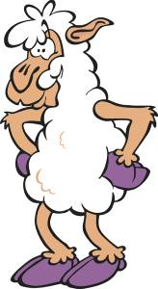

Life Stages

It’s important to be able to identify the particular life stage of an animal because this will affect how we feed and look after them. It’s important to try and know some of the terms used to describe sheep at different life stages:

All sheep are said to be ovine animals.

Adult Animals

- Adult animals are those that are fully-grown. They become mature at between 15-18 months of age.
- Only replacement ewes and a very select few tups will be kept until they are adults in the commercial sheep world.
- An adult entire male sheep is known as a tup in Scotland and a ram in the rest of the UK
- An adult female sheep is called a ewe.

Young animals

Lambs are young sheep between birth in the Spring and Christmas time.
Lambs are very small, with a poorly developed fleece when they’re born. They grow very quickly and can be up to 90% the size of their parents within 6 months.

Adolescent Animals

Adolescent animals are those that are growing up (after their first Christmas). They tend to keep their tight wool coat and are smaller than adult sheep.

- Hog or Hogg or Hogget are the terms used to describe both male and female adolescent sheep.
- Gimmer is the term used to describe female sheep in this category that are being kept as replacements for the old ewes.
- Wedder is the term used to describe an adolescent male sheep that has been castrated and is being fattened for meat.

Pregnant Animals

- Ewes are pregnant for approximately 5 months.
- It is difficult to recognise pregnancy in a ewe visually because they have such thick fleeces.
- Pregnancy diagnosis is often made by ultrasound examination early on: this allows the farmer to separate out the non-pregnant ewes from those having one lamb and those having two lambs. They are then fed differently.
- When a ewe is pregnant, she is said to be in lamb and when she gives birth, she is said ‘to lamb’

Lactating Animals

- lactating ewes are those that are producing milk for their lambs
- they can be recognised by their well-developed udder and the presence of lambs

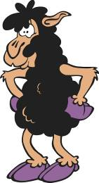Safety Tip!

- ewes are very protective of their lambs soon after lambing.
- sometimes you’ll be asked to help to move ewes and lambs and the best way to do this may be to carry the lambs and have the ewe follow you.
- you should be extra careful that the ewe does not head-butt you!

Activity

From the descriptions and information given, can you identify what life stage the following animals fall in to?

a) 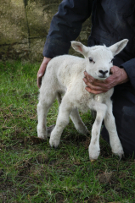 -----------------------------------------------------------

b)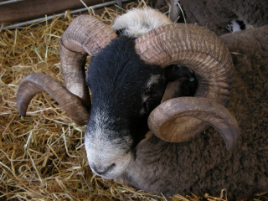 -----------------------------------------------

c) 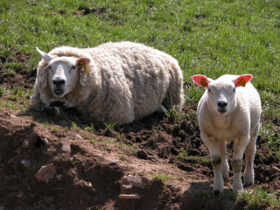 --------------------------------------------------

Answers

- This is obviously a lamb - but did you notice something odd about him? Yes, he does have an extra leg! It is uncommon but not completely unknown for lambs to be born with various types of deformity. For the record, ‘Jake’ here, survived fine and the vet removed his extra leg. Not all deformed lambs are so lucky though!
- This is an adult sheep. Horned breeds of sheep do not tend to have such well-developed horns until they are fully grown. This is a tup: they tend to have much larger horns than the ewes.
- This is a picture of a ewe and lamb. The ewe will therefore be lactating, which you can really only check by getting up close, but can assume so from the fact that the lamb is close by.

How to tell Male from Female Sheep

- ewes will normally have a visible udder if they have had lambs and you can also see their genitals if you part the wool between their hind legs.
- adult tups tend to be a little broader than ewes. It can sometimes be difficult to see their sheath below their belly and testicles between their hind legs without getting them couped first because of the thick wool coat. (Couping is the tipping up of sheep to look underneath them).
- the sheath is a protective skin guard for the male animal’s penis.
- wedders will be smaller than adult male animals. They have a sheath but no testicles (they have been castrated)

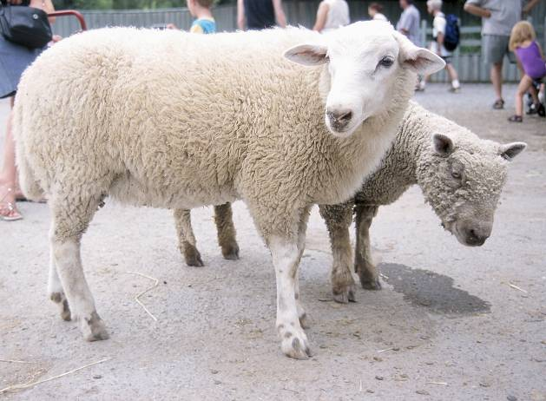

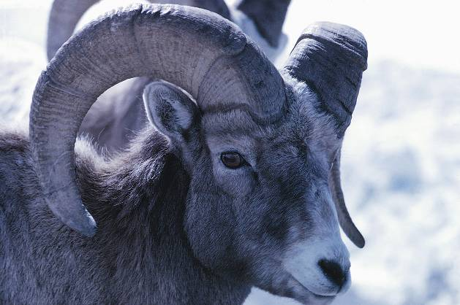
Activity

Using the descriptions given, can you identify the gender of the following sheep pictures?

a) 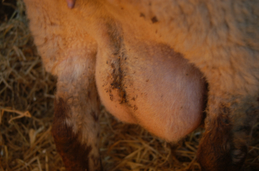 a)-----------------------------

b) 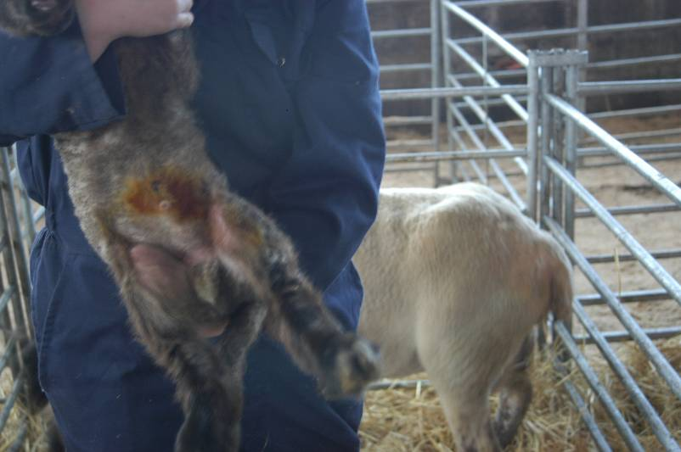b)------------------------------

Answer

- This is a picture of a ewe’s (very full) udder: so this is a female sheep.
- This is a picture of a small male (tup) lamb. You can see his sheath (near the orange area) and you can see his testicles. The orange area is an iodine preparation that has been sprayed on to his navel to help prevent infection from entering here.

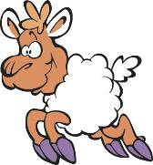

Signs of Health

We often instinctively know what a healthy animal is but can you think of some signs that lead us to the conclusion that a beast is in a good state of health?

Activity

List as many signs as you can think of that would indicate that a sheep is healthy.

Answer

There are many things that you can look for to identify that a sheep is healthy: some of them don’t even involve looking at the animal itself but rather examining its surroundings.

Here are some of the signs of health obvious from looking at the animal:

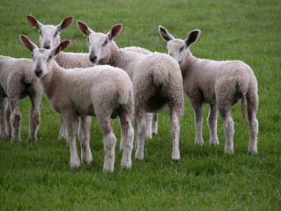

Figure 1: A group of healthy lambs

Signs of Health

- the fleece is complete and free from red/bald/sore areas or evidence of staining around the backend
- the body condition: well covered without being thin and bony (note that it would be necessary to handle the sheep to be able to tell this)
- the eyes are bright, without any discharge, films or white or dark spots over the eyes
- the gums and conjunctivae (this is the pink bit on the inside of the eye) are a salmon pink colour
- moving freely with no signs of lameness
- normal dung: no obvious signs of diarrhoea (scour)

Behavioural signs that indicate good health

- content and alert, showing interest in what is going on with no evidence of stress.
- chewing the cud (this where sheep regurgitate food from their stomachs and re-chew it to make it easier to digest) and eating happily
- demonstrating flock behaviour and coming forward to feed with the other sheep.
- food/water has been/is being eaten/drank

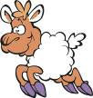 Top Tip!

Good husbandry means catching problems early: if you suspect a problem with any animal, always report it sooner rather than later.

Activity

Look at the picture below. This is not a healthy sheep. But can you identify at least one feature from the appearance of this sheep that helps you to recognise that it’s not healthy?

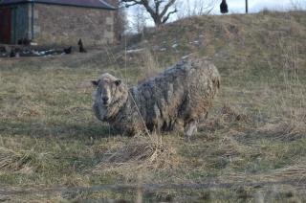 ------------------------------------

Answer

This ewe appears to be unable to stand up properly on her front legs. Her fleece is also very poor appearing dirty, grey and straggly. Compare her to the healthy group of lambs (of the Blue-headed Leicester breed) in Figure 1!

Other possible signs of ill-health

- a cough or obvious heavy breathing
- excessive or abnormal looking discharge from their eyes or nose
- signs of injury
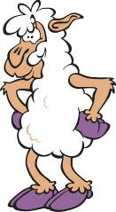Breeds

There are many breeds and recognised cross breeds of sheep throughout the world but it’s more important that we become familiar with the common breeds and cross breeds used in the British sheep industry. Crossbreeds are particularly important because the British sheep industry relies on the crossing of sheep to obtain the best quality of meat.

You may want to find out more about sheep breeds of the world. Here is a good web link that will provide links to various British sheep breed societies and information about different breeds:

http://www.nationalsheep.org.uk/pages/newframeset.htm: go to the list on the left and click on ‘UK Sheep Breeds’

Some of the common sheep breeds in the UK include:

The Scottish Blackface (‘Blackie’)

- These small sheep have a loose, long wool coat.
- They’re relatively small, both the males and females have horns and a patchy black and white face (hence the name) as well as black splodges on their legs.
- They’re very hardy and can survive in the hills of Scotland with little or no supplementary feeding.

The Cheviot

- A white-faced hill sheep from the Scottish Borders.
- They have fine hard white hair on their faces and legs.
- The fleece is relatively thick (tighter against the sheep’s body).
- The tups can have horns.

The Border Leicester

- This is a relatively large sheep with a longer coat than the Cheviot but not as loose as the Blackie.
- They have a distinctive roman nose and long legs.
- Their face and wool are white.
- They have no horns
- The Border Leicester is often crossed with the Blackface sheep to produce a ‘Greyface’. Greyface sheep are one of the most common crosses of ewe seen on lowland sheep farms in Scotland. They’re medium sized, with a shaggy fleece and a mottled grey and white face.

The Texel

- The Texel is a relatively ‘blocky’ sheep with a white face and an almost ‘snubbed’ nose.
- They have a short neck and a very tight and crinkled fleece.

Activity

From the descriptions above, can you identify the breeds and crossbreeds of sheep from the following pictures?

a) 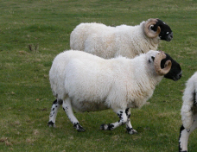 a) -------------------------------------------

b) 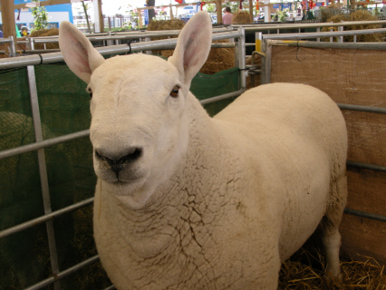 b) -------------------------------------------
c) 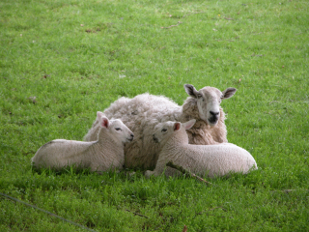 c) -------------------------------------------
Answer

- This is a picture of two young Scottish Blackface tups. Notice their horns, black patches on the legs and face.
- This is a difficult one - well done if you got this from just the description. This is a Cheviot tup. He has a white face and tight wool around his legs. He has no horns (but some of them do). It would have been easy to confuse him with a Texel - can you see the difference when you look at this picture below of a Texel ewe - she almost looks as if she has no neck and is very ‘blocky’?

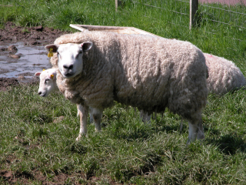
Figure 2: Texel ewe

- This is a Grey face ewe with her lambs - notice her mottled grey face and loose fleece.

Preparing Sheep Accommodation and Mucking Out

Sheep are not often housed except for lowland farm sheep during lambing time. This is because they’re designed to live outdoors and can develop bad breathing problems, if kept indoors for too long. However, when lambing occurs earlier in the year than perhaps nature intended (normally sheep will lamb between March and May), it’s useful to have them housed because the lambs can easily become very cold (hypothermic) and die if they are reared outdoors in severe weather.
To keep the building airy (well-ventilated), sheep housing is usually made up of temporary lambing pens within a large, open shed. Hurdles (small gates that fix together) or straw bales may be used to make walls to the pens.

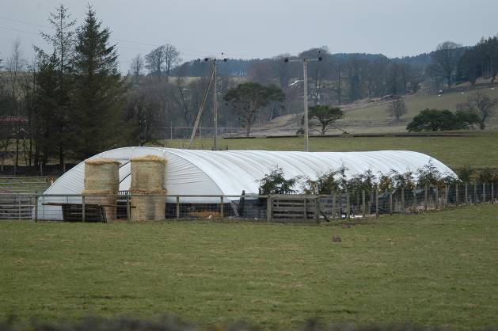

Figure 3: A plastic tunnel adapted to become a lambing shed

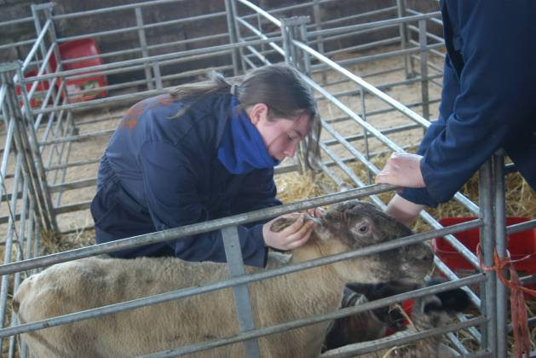

Figure 4: A ewe has her ear tag examined in a lambing pen (lambs also in pen)
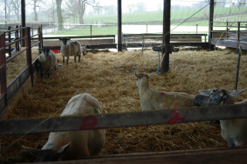

Figure 5: Lambing shed - pregnant ewes

This picture shows another shed where the ewes that have not yet lambed are housed in a larger pen. When they lamb they will be moved to a small pen like the one in Figure 4. Notice that the front of the shed is open. If you look closely, you can make out the green mesh that is acting as a ‘wind-break’ to the shed.

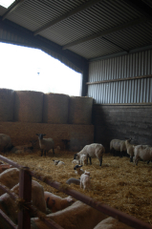

Figure 6: Lambing shed: newly lambed ewes

This picture shows a large pen in the shed with ewes and lambs. This is where ewes and lambs would be moved to after a day or two from birth. Note that the end wall is made up of stacked straw bales.

The lambs will usually have their navels treated with iodine spray (see picture b in the Activity on page 43) before being grouped together like this. Infection is a big risk at lambing time and it can often get into the lambs through their navels. Hygiene is very important and so is ensuring that the shed always has a plentiful supply of fresh bedding.

Bedding

Straw

Straw is the normal bedding material of sheep sheds.

Straw is the stalk of grain and so it is a bi-product of harvesting wheat, barley and oats. It sometimes comes in small square bales which can be handled by one or two people, but more often nowadays, it comes in large round bales which need to be moved around by a tractor and spike.

Straw can sometimes be dusty and contain harmful fungi. If it’s very dusty, it’s not good for you or the cattle.

Safety Tip!
You should always wear a facemask if you are working with dusty straw.

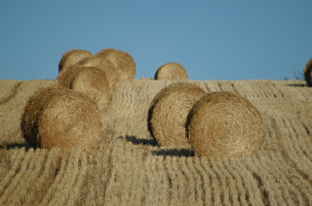

Figure 7: Large round straw bales in a field

Tasks that you may well be involved in include:

- the setting up of the lambing pens (building the hurdles or bale walls and putting down the bedding)
- placing fresh bedding into pens
- mucking out the lambing pens at the end of the lambing season
- hosing out the sheds after lambing time has finished and they have all been turned ‘out to grass’

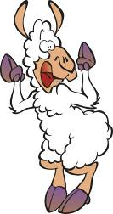 Top tips to impress your tutor!

Things to think about:

- always turn up on time and be ready to start when the tutor tells you to
- always work co-operatively with your co-workers: share tasks out fairly
- always try to use bedding efficiently: you don’t want to waste lots of straw that can be re-used: that is wasteful of resources and money! Wasting money is one of the best ways to upset your boss. However, remember that you must balance this with the welfare of the animals - if animals are kept in poor conditions they will often become ill.
- always work safely: be correctly dressed and ready to work
- follow instructions carefully and ask about anything that you are unsure about

Activity

Reflect on how things went when you mucked out or set up lambing pens for the first time:

I was good at:

I need to get better at:

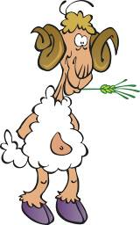

Feeding and Watering Sheep

Sheep are ruminants. This means that they are vegetarians with four stomachs, one of which has been specially adapted to digest fibrous foods (roughage or forage). This special stomach is called the rumen. They’re very similar to cattle in this respect.

Their staple food is grass and some hardy hill sheep will be fed nothing extra except for perhaps a vitamin and mineral supplement block.
Vitamins and minerals are food supplements that are necessary for normal growth, repair and function of the body.

Types of Roughage (preserved grass)

The main types of preserved grass are hay and silage. This will be fed to lowland sheep during the last two months of pregnancy and the first few weeks of lactation. As mentioned before, hill and upland farm sheep, may not receive extra feeding for a long a period of time.

Silage

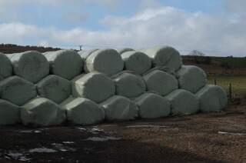

Figure 8: Silage bales, wrapped in plastic, normally black, sometimes green

Silage is pickled grass and tends to be wrapped in plastic bales or is made in a large silage clamp which is a large concrete pit that is covered over. The farmer will take sections of silage to feed to the sheep and place it, either out in the field, on the ground or in a ring-feeder.

The plastic wrapper of the silage is removed before feeding to the sheep.

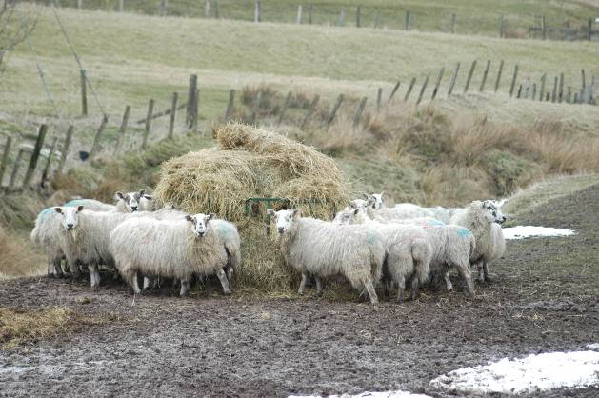

Figure 9: Sheep eating silage from a ring feeder in the wintertime

Hay

Hay is very dry and comes in bales (large round ones or smaller square ones, like the straw). It is a more traditional roughage food for sheep but is still quite often fed to sheep by many farmers.

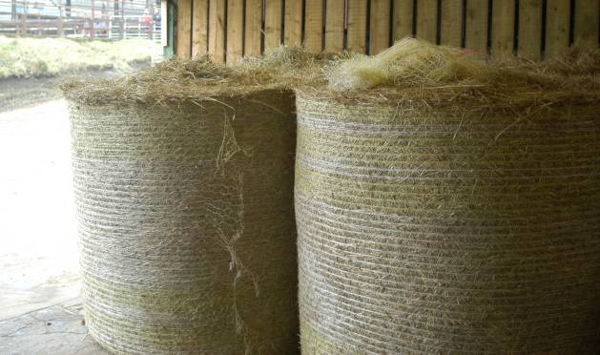

Figure 10: Large round hay bales

Other Types of Sheep Feed

Flaked Barley and Oats

These are cereals given to sheep that have a high-energy requirement because they are in late pregnancy or early lactation. They may be mixed with a mineral and vitamin supplement, soya bean meal and sugar beet pulp to balance the diet.

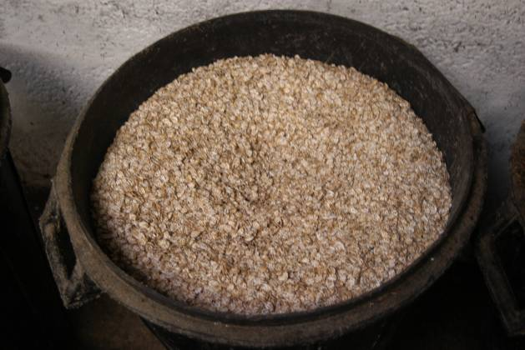

Figure 11: Raw, flaked barley

A home mix (of the ingredients described above) is a cheaper way to feed sheep than to buy ready mixes.

Sheep Nuts or Cobs

Theses are ready prepared balanced sheep feeds that are designed to be fed alongside any roughage supplement

Roots (Turnips and Swedes)

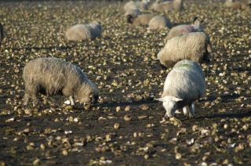

Figure 12: Sheep eating turnips in a field

Turnips and swedes are sometimes fed to sheep in the autumn. They do not have a very high feed value due to their high water content. The sheep are normally turned out into a field of roots and can ‘graze’ them at will.

Vitamin and mineral blocks and liquid feeds

These blocks are designed to supply sheep that live on poor grazing with extra vitamins and minerals. They require very little maintenance once they have been placed in the field but it can be difficult to know how much the sheep are using them!
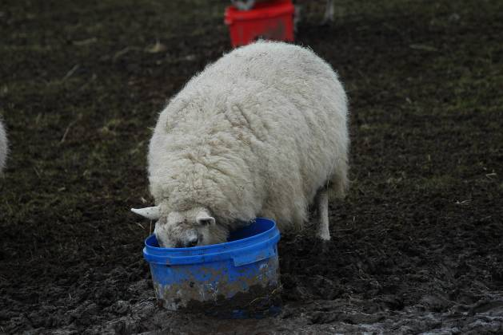

Figure 13: A ewe eating out of a bucket containing a vitamin/mineral block feed

Unlike cattle, the concentrate part of a ewe’s diet is not normally fed mixed with the silage or hay. They may be fed in troughs or on the ground in a long line. When they are fed in troughs, the amount fed is calculated on the basis of the number of ewes in the pen or field. It’s therefore very important that:

- the trough or ground where the food is being spread out is dry and clean
- enough trough space is allowed to make sure that all the ewes can get forward to the trough
- the food is placed evenly along the trough

Otherwise, some of the less ‘pushy’ ewes will end up with nothing and become very weak.

There’s no substitute for practice when preparing and providing food. You’ll be given a demonstration on how and when the feeds should be prepared and given plenty of opportunity to practise!

Important tasks that you’ll be involved in include:

- cleaning food troughs ready for use
- distributing both roughage and other foods to sheep
- if feeding silage, the wrapping should be disposed of in a bin as the plastic can be harmful to the environment (and animals)
- moving troughs away from an area (because the ground has become poached)
- tipping troughs up (to prevent mud and rain getting in to them, after feeding)
- feeding young lambs a supplementary milk substitute

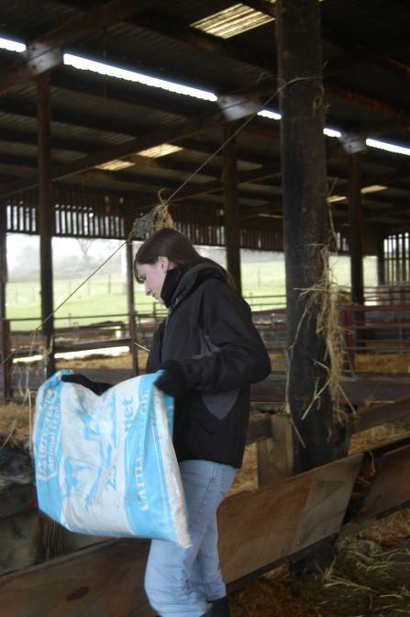

Figure 14: Feeding the lactating ewes in the lambing shed



Figure 15: Bottle feeding a lamb

Ewes normally have one or two lambs but can sometimes have more (which can be a problem because they only have two teats: extra lambs have to be fostered onto another ewe that has lost her lambs or be fed by a bottle). Pet lambs are those that are reared entirely on bottled milk.

Watering Sheep

Sheep should have a clean, fresh supply of water at all times. This may be provided in buckets or, much more likely, in automatic water drinkers or troughs. When sheep are outside, their main water supply is likely to be from natural supplies such as streams, rivers or ponds.

Important tasks that you could be involved in include:

- checking that the water drinkers are clean and working
- checking that the natural water supply is easily reached and has no obvious signs of pollution that could harm the sheep

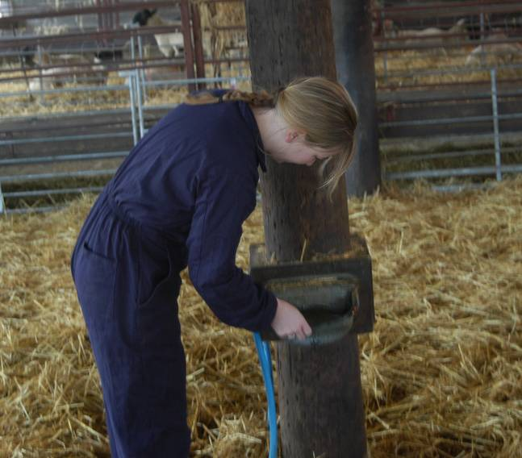

Figure 16: Cleaning the water drinker

Top Tips

Things to think about:

- always work safely: be correctly dressed, ready to work; do not muck about
- always work co-operatively with your co-workers: share tasks out fairly
- always feed and provide water exactly as you are told: if you are unsure then ask!
- follow instructions carefully and ask about anything that you are unsure about
Activity

Can you think of one advantage and one disadvantage for water troughs?

Advantage:

Disadvantage:

Can you think of one advantage and one disadvantage for natural water supplies?

Advantage:

Disadvantage:

Answer

Advantages of water troughs:

- Water troughs are labour-saving and ensure that there is always fresh water available for the sheep. Labour-saving ideas are very important on farms and troughs and drinkers are therefore the most common way to provide water to sheep.

Disadvantages of water troughs:

- Water troughs can become dirty, can allow transfer of infection from one animal to another and it’s difficult to identify how much an animal is drinking.
- They can be quite expensive to install initially and may leak or break.
- They need to be checked regularly.

Advantages of natural water supplies:

- There is very little maintenance required for natural water supplies.
- They are free flowing and usually plentiful in supply.

Disadvantages of natural water supplies:

- Natural water supplies can become inaccessible, e.g. if the field gate is closed accidentally.
- Chemicals put in them further upstream can sometimes contaminate them.
- They can dry up in the summer months.

Self-assessment

Now that you have had a chance to practise the various skills and found out more about cattle husbandry, you can have a go at answering the following questions:

Tick the correct box.

- What do we call an entire adult male sheep in Scotland?
- a heifer
- a stirk
- a wedder
- a tup
- Which one of the following breeds is not a sheep breed?
- Ayrshire
- Scottish Blackface
- Border Leicester
- Cheviot
- Chewing the cud is when sheep:
- grind their teeth
- regurgitate food and re-chew it
- relax and sleep
- pass dung
- Which of the following is not a sign of good health in sheep?
- coming forward with other sheep to eat at troughs
- fleece falling out in lumps
- chewing the cud
- bright eyes

- A ewe can be pregnant for roughly 5 months:
- True
- False
- Weaning is:
- the correct term for a pregnant ewe
- the production of milk
- the removal of the young lambs from the ewe
- the placing of sheep in chemical baths
- Sheep are sometimes fed turnips in the autumn:
- True
- False
- Dried preserved grass is called:
- hay
- ryegrass
- straw
- silage
- A disadvantage of feeding sheep in troughs is:
- they can become dirty
- they can poach the ground around the troughs
- some sheep may not get enough because of crowding
- all of the above
- Some sheep never come indoors to lamb:
- True
- False

How did it go?

Check your answers against the grid.
Answers

Question | Correct answer
1 | d) a tup
2 | a) Ayrshire
3 | b) regurgitate food and re-chew it
4 | b) fleece falling out in lumps
5 | a) True
6 | c) the removal of the young lambs from the ewe
7 | a) True
8 | a) hay
9 | d) all of the above
10 | a) True

Activity

You may also want to have a go at the PowerPoint quiz about sheep husbandry, located on the Skills for Work pages on the SFEU website www.sfeu.ac.uk.

Practical Activities Worksheets

This section contains practical worksheets that may be useful in getting students to reflect on what they’ve learned in practical activities.
Practical Worksheet 1

Name: ……………………………………... Date: ………………………………..

You’ve been looking at a group of sheep today. Answer the following questions on what you found out about them.

Answer
- Why were these sheep being kept?
- What sort of age group were they (young, adolescent, adult, lactating or pregnant)?
- Did they all seem healthy?
- List 5 signs of health that you noticed in the healthy ones.
- If there were any that did not appear healthy, what signs made you think that they were not healthy?
- Were they all the same sex?
- List the breeds or cross breeds of the sheep that you saw.
Practical Worksheet 2

Name: ……………………………………... Date: ………………………………..

You were looking at how some sheep were kept and the equipment that is used in order to keep them fit and well. Answer the following questions on today’s activities.

Answer
- How were these sheep housed?
- What type of bedding did they have?
- What are the routine tasks needed to maintain the welfare of the sheep?
- What tools and equipment are needed to bed the sheep?
- Do these sheep stay in this type of housing throughout the year?
- If the answer to the above question is no, then what happens to them next and when?
- List 3 rules that you have been asked to follow when working with these sheep.
Practical Worksheet 3

Name: ……………………………………... Date: ………………………………..

You’ve been involved in cleaning and setting up some sheep housing today. Answer the following questions:

Answer
- What type of sheep housing were you involved in bedding today?
- Briefly describe the tasks that you helped with in bedding the sheep.
- Were there any problems? If the answer is yes, explain briefly what happened.
- Is there anything that you would do the next time you do this that might make it easier and more efficient?
- How often does this task have to be done?

Practical Worksheet 4

Name: ……………………………………... Date: ………………………………..

You have been involved in feeding and watering sheep today. Answer the following questions:

Answer
- What type of sheep were you feeding today?
- How often does this task have to be done?
- Briefly explain what was being done.
- Briefly explain what you did to help.
- Were there any problems? If the answer is yes, explain briefly what happened.
- What hazards did you discuss with your tutor before you carried out the task?
- List two safety rules that you had to follow in order to carry out this task.
- Is there anything that you would do the next time you do this that might make it easier and more efficient?

Practical Assessment Checklist

This checklist will help you to understand what your tutor will be looking for when you’re doing the practical assessments in this unit. Use this checklist to think about whether you are doing all these things when you are practising for the assessment tasks and to work out what you need to improve on.

Can I: | Yes / No | Things I need to work on or get help with
- demonstrate that I know how to tell the difference between male and female sheep
- identify 5 signs of health from looking at sheep
- identify 2 common breeds of sheep from the ones that I’ve learned about
- recognise young, adolescent, adult or sheep by looking at them
- help to muck out a sheep pen
- help to bed out a sheep pen
- prepare feeds for sheep (including removing the strings/wrapping from silage/hay)
- help to give feeds and water to sheep
- carry out all of these tasks safely

Further Revision

Sheep Husbandry Crossword

 |  | 1 | 2 |  |  |  |  |  |  |  |  |  |  | 3
 |  |  |  |  |  |  |  |  |  |  |  | 4
 |  | 5
 |  |  |  |  |  |  |  |  |  | 6 |  | 7
 | 8
9
 |  | 10
11
 |  |  | 12
 | 13
 | 14 |  |  |  |  |  | 15
 |  |  |  |  |  |  | 16
 |  |  |  |  |  | 17

  Across:
  1 | the act of caring for animals to ensure their health and well being (9)
  4 | of the species that sheep are; begins with O (5)
  5 | the woolly coat of sheep (6)
  7 | born in the springtime, the young of a sheep (4)
  9 | A breed of sheep, crossed with a blackface sheep to make a greyface sheep (6, 9)
  10 | when sheep and cattle regurgitate their food and re-chew it we commonly call this (c the c)
  11 | chemicals that sheep are bathed in order to kill parasites on their coats (5,3)
  12 | a group of sheep cared for by a shepherd (5)
  14 | gates that can be linked together in order to make temporary fences (7)
  16 | another name for a ram (3)
  17 | dried preserved grass, often fed to sheep (3)
  Down:
  2 | a sheep farm that is not on the hills or on the lowlands is called an (6,5,4)
  3 | a young female sheep that has not yet had any lambs (6)
  6 | an adult female sheep (3)
  8 | an adolescent male or female sheep (3)
  13 | a sheep that has had its fleece removed is said to be .....(5)
  15 | yellow, natural material that is used for bedding (5)

Solution

Sheep Husbandry Crossword

 |  | 1 H | 2 U | S | B | A | N | D | R | Y |  |  |  | 3 G
 |  |  | P |  |  |  |  |  |  |  |  | 4 O | V | I | N | E
 |  | 5 F | L | E | E | C | E |  |  |  |  |  |  | M
 |  |  | A |  |  |  |  |  |  | 6 E |  | 7 L | A | M | B
 | 8 H |  | N |  |  |  |  |  |  | W |  |  |  | E
9 B | O | R | D | E | R | L | E | I | C | E | S | T | E | R
 | G |  | S
 |  | 10 C | H | E | W | I | N | G | T | H | E | C | U | D
 |  |  | E
11 S | H | E | E | P | D | I | P
 |  |  | P
 |  |  | 12 F | L | O | C | K
 | 13 S |  | A
 | 14 H | U | R | D | L | E | 15 S
 | O |  | M |  |  |  | 16 T | U | P
 | R |  |  |  |  |  | R
 | N |  |  |  |  | 17 H | A | Y
 |  |  |  |  |  |  | W

Glossary of Terms

Adolescent | growing up: between young and adult
Bales | a package of hay or straw usually made by a machine and tied up with string called ‘baler twine’
Castrated | a male animal that has had its testicles removed
Chewing the cud | regurgitating food to re-chew; part of the normal digestive process of sheep
Coup/couped | turning a sheep on to its bottom in order to inspect or treat it
Croft | A small farm, normally in Highland and Island areas of North West Scotland where less intensive farming takes part as part of the community.
Ewe | an adult female sheep
Fleece | the wool coat of a sheep; in general, the tighter the wool fleece, the more value it has after shearing
Flock | the correct term for a group or herd of sheep
Gimmer | an adolescent female sheep (15-18 months old)
Hay | a preserved form of grass; a less common feedstuff for cattle in intensive systems
Hill sheep farm | a farm where hardy sheep are kept; these farms are 500m or more above sea level
Hog/Hogg/Hogget | an adolescent sheep either male or female (after their 1st Christmas)
Hurdles | gates that can be clipped together to form pens or runways
Husbandry | care to ensure the health and well-being.
Hypothermic | Hypothermia is a medical state when an animal is extremely cold and its body temperature drops. This is a very common cause of death in lambs.
Intensive | Intensive farming systems are those where the number of animals is greater than can be supported just by the land of the farm. This means that extra feeding and work is required to maintain the welfare of the animals.
Lactation (lactating) | the life stage when milk is being produced (ewes only)
Lamb | this is a young sheep between birth and their first Christmas; it is also the term used for their meat
Lowland sheep farm | This is a sheep farm where sheep are bred for fastest weight gain. The sheep kept may not be as hardy as those on hills or upland farms. Lowland farms are 300m or less above sea level.
Navel | This is the cord where the lamb was attached to its mother in the womb. It is a common route for infection and should be treated in lambs.
Ovine | of sheep, of that species; sheep are ‘ovine’ animals
Poaching/poached | where the ground becomes very wet, muddy and churned up: a source of bugs that can lead to illness in sheep
Ring Feeder | a round metal holder for placing round bales of silage in; used to feed sheep inside and outside
Roughage/Forage | the fibre part of sheep diet which is essential for them; this may be grass, silage or hay
Rumen | this is the large compartment of the sheep’s stomach (of which there are four), where fibre is digested
Ruminant | an animal that has a rumen; they also have no top teeth at the front!
Scour | scour is the name given to diarrhoea in sheep; it is a common problem, particularly in lambs
Shearing/shorn | Shearing is the act of removing the sheep’s fleece which is done by clipping in the early summer to stop them from over-heating. Sheep that have had their fleeces removed are described as ‘shorn’.
Shearling | a tup that is between her first and second shearing
Sheath | the protective outer skin that covers a male animal’s penis
Sheep dip/dipping | Sheep are very prone to developing skin parasites. They are often dipped in a chemical bath, usually in the autumn to get rid of parasites and to help to prevent them occurring. They may also undergo cosmetic dipping before the sheep sales.
Silage | pickled grass often fed to sheep; may be wrapped in plastic or stored in a clamp which is a large concrete pit
Straw | the stalk of cereals such as barley or wheat; used as bedding material for sheep
to lamb | to give birth
Tup/Ram | male sheep complete with testicles
Udder | the mammary glands of the ewe; the ewe’s udder has 2 teats
Upland sheep farm | These are sheep farms that are between 300-500m above sea level. The sheep kept here will be less hardy than on the hill but more hardy than lowland farms.
Wean | to remove the young animal from its mother’s milk; lambs are generally weaned at between 12 and 16 weeks of age.
Wedder | term for an adolescent neutered (castrated) male sheep which is being fattened

